**CO1: Set up the Android development environment and debug apps using emulator and Logcat.**

**Experiment 1: First Run App**

**Objective:** To successfully set up a basic android project and run it on either an android emulator or a physical android device

**Question:** create a new empty view activity Android project in android studio without making any code changes, successfully run this default empty app on an android emulator.take a screenshot of the app running on the emulator.if you have a physical Android phone,also try to run the app on your phone and take a screenshot

**MainActivity.java**

package com.example.application1;

import android.os.Bundle;

import androidx.activity.EdgeToEdge;

import androidx.appcompat.app.AppCompatActivity;

import androidx.core.graphics.Insets;

import androidx.core.view.ViewCompat;

import androidx.core.view.WindowInsetsCompat;

public class MainActivity extends AppCompatActivity {

@Override

protected void onCreate(Bundle savedInstanceState) {

super.onCreate(savedInstanceState);

EdgeToEdge.enable(this);

setContentView(R.layout.activity_main);

ViewCompat.setOnApplyWindowInsetsListener(findViewById(R.id.main), (v, insets) -> {

Insets systemBars = insets.getInsets(WindowInsetsCompat.Type.systemBars());

v.setPadding(systemBars.left, systemBars.top, systemBars.right, systemBars.bottom);

return insets;

});

}

}

**activity_main.xml**

<?xml version="1.0" encoding="utf-8"?>

<androidx.constraintlayout.widget.ConstraintLayout xmlns:android="http://schemas.android.com/apk/res/android"

xmlns:app="http://schemas.android.com/apk/res-auto"

xmlns:tools="http://schemas.android.com/tools"

android:id="@+id/main"

android:layout_width="match_parent"

android:layout_height="match_parent"

tools:context=".MainActivity">

<TextView

android:layout_width="wrap_content"

android:layout_height="wrap_content"

android:text="Hello World!"

app:layout_constraintBottom_toBottomOf="parent"

app:layout_constraintEnd_toEndOf="parent"

app:layout_constraintStart_toStartOf="parent"

app:layout_constraintTop_toTopOf="parent" />

</androidx.constraintlayout.widget.ConstraintLayout>

**Output**

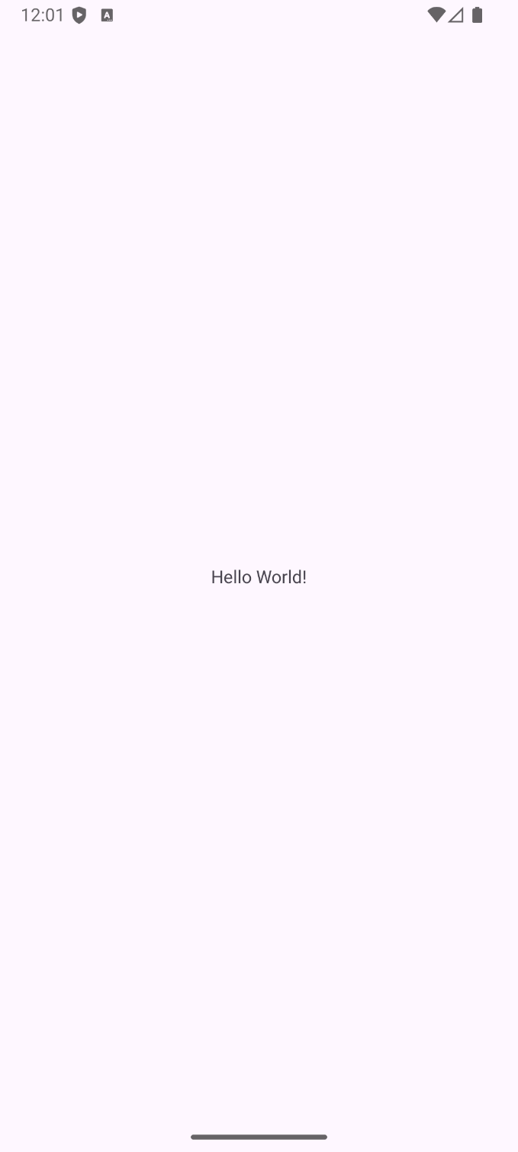

**Experiment 2: "Logcat Debugging Basics"**

**Objective:** To learn how to use Logcat in Android Studio to view application messages and system logs for basic debugging.

**Question:** Open your "Hello, Interactive World!" app from CO1. In your MainActivity.java file, inside the onCreate () method, add a simple log message using Log.d("MyTag", "App is starting!"); Run the app. Then, open the Logcat window in Android Studio and find your custom log message. Demonstrate how to filter Logcat to show only messages from your app using the tag "MyTag

**MainActivity.java**

package com.example.application1;

import android.os.Bundle;

import android.util.Log;

import androidx.activity.EdgeToEdge;

import androidx.appcompat.app.AppCompatActivity;

import androidx.core.graphics.Insets;

import androidx.core.view.ViewCompat;

import androidx.core.view.WindowInsetsCompat;

public class MainActivity extends AppCompatActivity {

@Override

protected void onCreate(Bundle savedInstanceState) {

super.onCreate(savedInstanceState);

EdgeToEdge.enable(this);

setContentView(R.layout.activity_main);

ViewCompat.setOnApplyWindowInsetsListener(findViewById(R.id.main), (v, insets) -> {

Insets systemBars = insets.getInsets(WindowInsetsCompat.Type.systemBars());

v.setPadding(systemBars.left, systemBars.top, systemBars.right, systemBars.bottom);

return insets;

});

Log.d("my tag","app is starting");

}

}

**Output**

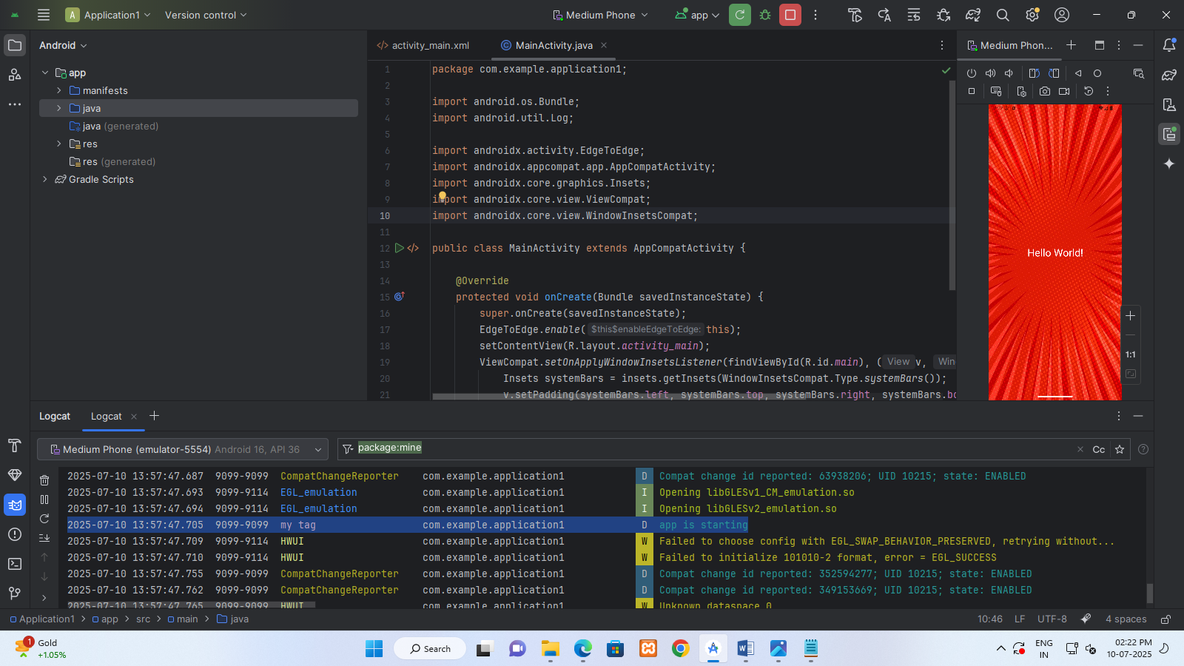

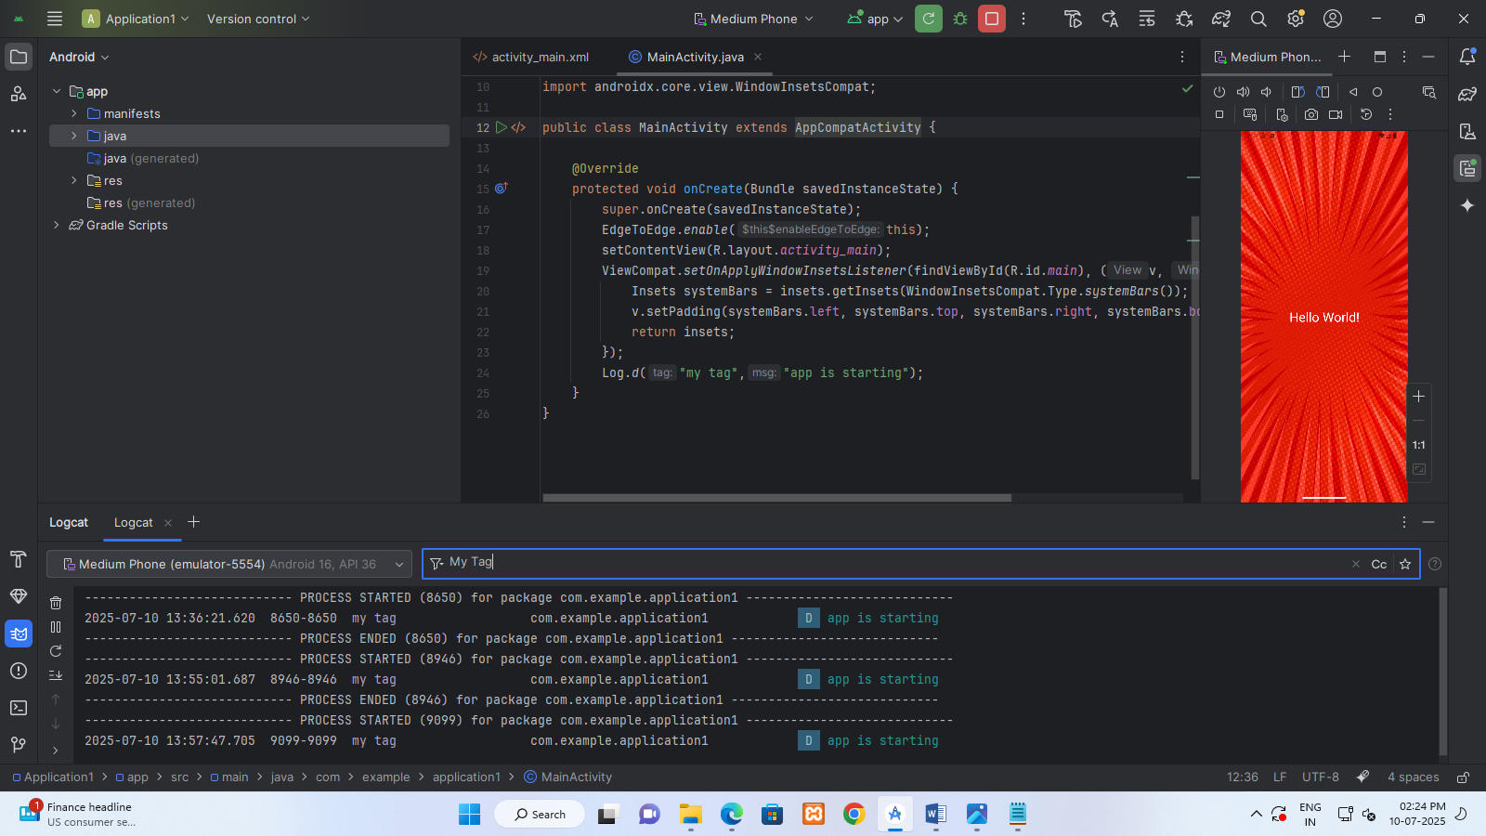

**CO2: Understand Android components, app structure, and activity lifecycle.**

**Experiment 3: "Hello, Interactive World!“**

**Objective:** To learn how to make a button change text on the screen and show a quick message.

**Question:** Make a simple Android app. Design its main screen (activity_main.xml) to include a TextView that initially displays "Hello World!" and a Button labelled "Change Greeting". Write the code

(MainActivity.java) so that when the "Change Greeting" button is clicked, the TextView updates its text to "Welcome to Android!"

**MainActivity.java**

package com.example.application1;

import android.os.Bundle;

import android.view.View;

import android.widget.Button;

import android.widget.TextView;

import androidx.appcompat.app.AppCompatActivity;

public class MainActivity extends AppCompatActivity {

private TextView Message ;

private Button Click;

@Override

protected void onCreate(Bundle savedInstanceState) {

super.onCreate(savedInstanceState);

setContentView(R.layout.activity_main);

Message = findViewById(R.id.textViewGreeting);

Click = findViewById(R.id.button);

Click.setOnClickListener(new View.OnClickListener() {

@Override

public void onClick(View v) {

Message.setText("Welcome to Android");

}

});

}

}

**activity_main.xml**

<?xml version="1.0" encoding="utf-8"?>

<androidx.constraintlayout.widget.ConstraintLayout xmlns:android="http://schemas.android.com/apk/res/android"

xmlns:app="http://schemas.android.com/apk/res-auto"

xmlns:tools="http://schemas.android.com/tools"

android:id="@+id/main"

android:layout_width="match_parent"

android:layout_height="match_parent"

android:background="@drawable/img2"

tools:context=".MainActivity">

<TextView

android:id="@+id/textViewGreeting"

android:layout_width="wrap_content"

android:layout_height="wrap_content"

android:layout_marginTop="282dp"

android:layout_marginEnd="88dp"

android:text="Hello World!"

android:textColor="@color/white"

android:textSize="32dp"

app:layout_constraintEnd_toEndOf="parent"

app:layout_constraintTop_toTopOf="parent" />

<Button

android:id="@+id/button"

android:layout_width="wrap_content"

android:layout_height="wrap_content"

android:layout_marginTop="43dp"

android:layout_marginEnd="40dp"

android:text="Change Greeting"

app:layout_constraintEnd_toEndOf="@+id/textViewGreeting"

app:layout_constraintTop_toBottomOf="@+id/textViewGreeting" />

</androidx.constraintlayout.widget.ConstraintLayout>

**Output**

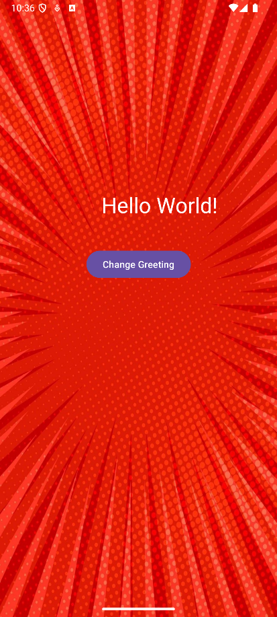 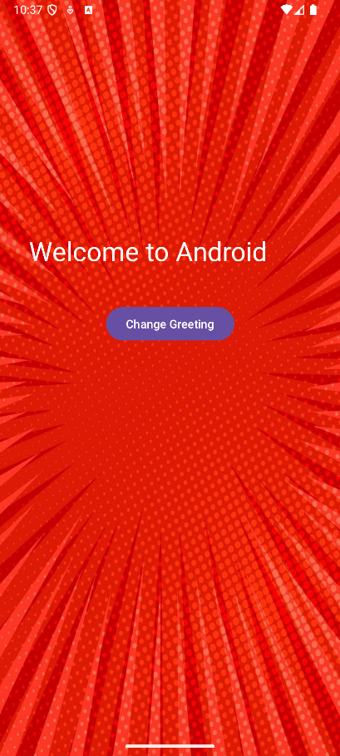

**Experiment 4: "Understanding Activity Lifecycle“**

**Objective:** To understand the various states an Android Activity goes through during its lifetime (its lifecycle) and to observe these transitions using Logcat.

**Question:** Write an Android program that demonstrates the Activity lifecycle

**MainActivity.java**

package com.example.application1;

import android.os.Bundle;

import android.util.Log;

import androidx.appcompat.app.AppCompatActivity;

public class MainActivity extends AppCompatActivity {

private static final String TAG ="LifeCycle";

@Override

protected void onCreate(Bundle savedInstanceState) {

super.onCreate(savedInstanceState);

setContentView(R.layout.activity_main);

Log.d(TAG,"OnCreate()-Activity is being created");

}

@Override

protected void onStart() {

super.onStart();

Log.d(TAG,"OnStart()-Activity is visible");

}

@Override

protected void onResume() {

super.onResume();

Log.d(TAG,"OnResume()-Activity is interactive");

}

@Override

protected void onPause() {

super.onPause();

Log.d(TAG,"OnPause()-Activity is paused");

}

@Override

protected void onStop() {

super.onStop();

Log.d(TAG,"OnStop()-Activity is stopped");

}

@Override

protected void onDestroy() {

super.onDestroy();

Log.d(TAG,"OnDestroy()-Activity is destroyed");

}

@Override

protected void onRestart() {

super.onRestart();

Log.d(TAG,"OnRestart()-Activity is restarted");

}

}

**Output**

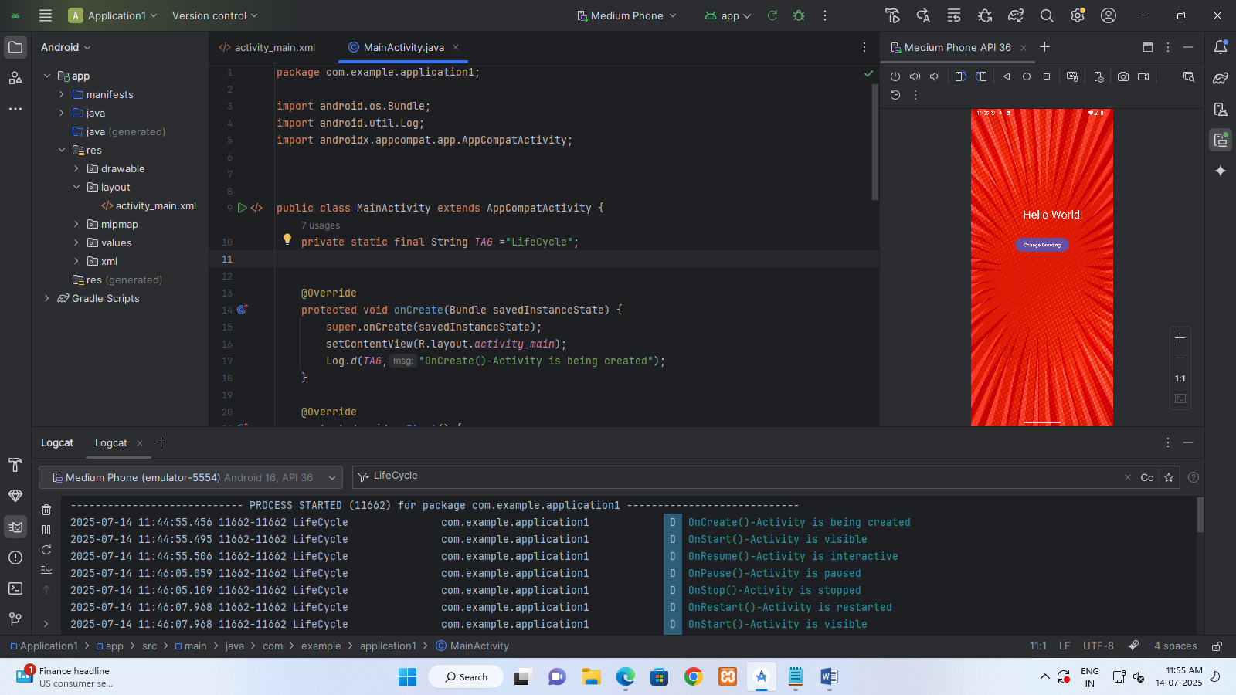

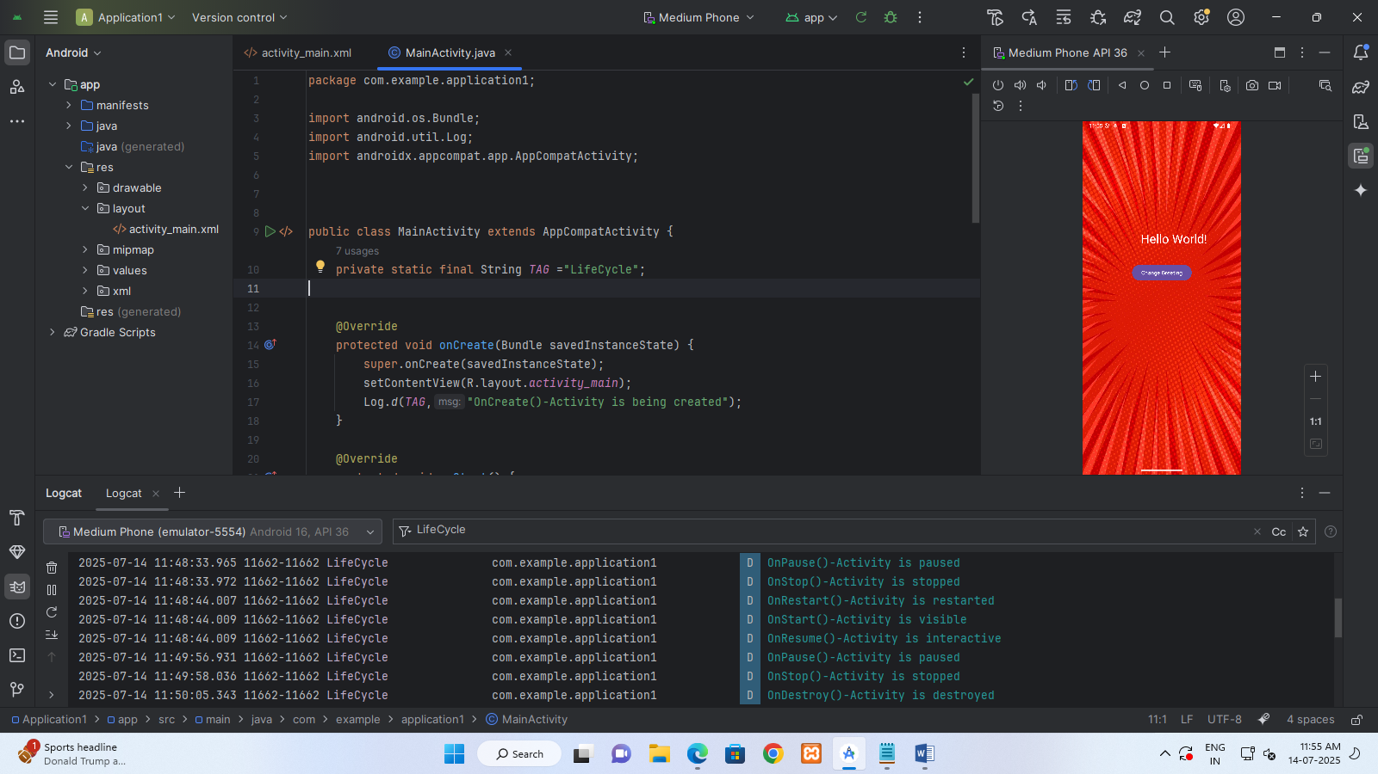

**CO3: Design basic and advanced user interfaces using layouts, widgets, dialogs, and fragments**

**Experiment 5: "TextView vs. Toast: Message Display“**

**Objective:** To clearly demonstrate and differentiate between the characteristics and appropriate use cases of a TextView (for persistent UI display) and a Toast message (for transient, non-intrusive feedback) in an Android application.

**Question:** Design an Android application to demonstrate the differences between TextView and Toast messages in terms of how they display information.

**MainActivity.java**

package com.example.experiment5;

import android.os.Bundle;

import android.view.View;

import android.widget.TextView;

import android.widget.Toast;

import androidx.appcompat.app.AppCompatActivity;

public class MainActivity extends AppCompatActivity {

@Override

protected void onCreate(Bundle savedInstanceState) {

super.onCreate(savedInstanceState);

setContentView(R.layout.activity_main);

TextView textView = findViewById(R.id.textView);

textView.setText("This is a text displayed on textview");

}

// Button click handler

public void showToastMessage(View view) {

Toast.makeText(this, "This is a tost notification",

Toast.LENGTH_LONG).show();

}

}

**activity_main.xml**

<?xml version="1.0" encoding="utf-8"?>

<LinearLayout xmlns:android="http://schemas.android.com/apk/res/android"

android:layout_width="match_parent"

android:layout_height="match_parent"

android:orientation="vertical"

android:padding="16dp"

android:gravity="center">

<TextView

android:id="@+id/textView"

android:layout_width="wrap_content"

android:layout_height="wrap_content"

android:textSize="18sp"

android:padding="12dp"

android:background="#E0E0E0"

android:layout_marginBottom="32dp"/>

<Button

android:layout_width="wrap_content"

android:layout_height="wrap_content"

android:text="show toast message"

android:onClick="showToastMessage"

android:backgroundTint="#6200EE"

android:textColor="#FFFFFF"/>

</LinearLayout>

**Output**

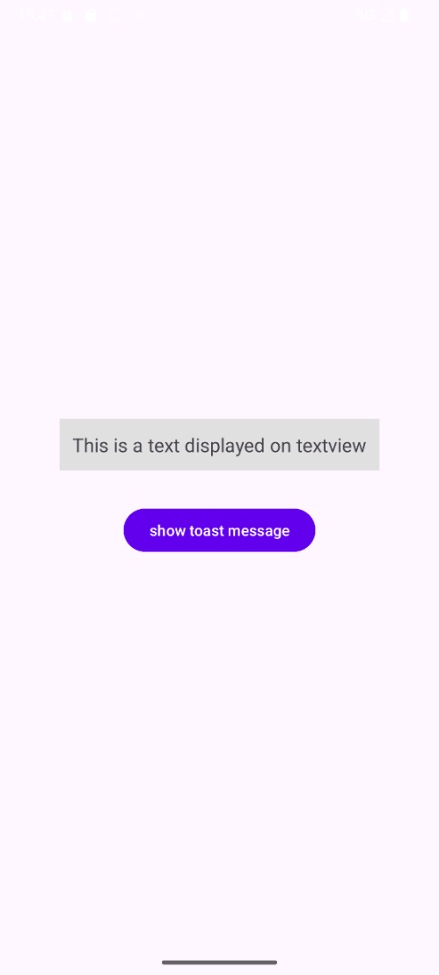 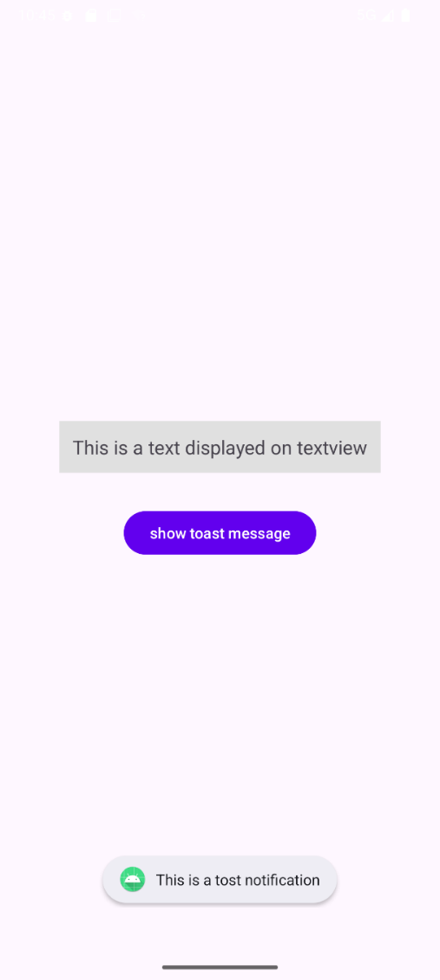

**Experiment 6: "Basic Login and Input Display“**

**Objective:** To learn how to use EditText for user input, arrange UI elements using LinearLayout, and retrieve input data to display in aToast message.

**Question:** Design a basic Login Form with places for username and password. Use a Linear Layout to arrange them, and show a message using a Toast.

**MainActivity.java**

package com.example.experiment6;

import android.os.Bundle;

import android.view.View;

import android.widget.Button;

import android.widget.EditText;

import android.widget.Toast;

import androidx.appcompat.app.AppCompatActivity;

public class MainActivity extends AppCompatActivity {

EditText username;

EditText password;

Button loginButton;

@Override

protected void onCreate(Bundle savedInstanceState) {

super.onCreate(savedInstanceState);

setContentView(R.layout.activity_main);

username=findViewById(R.id.username);

password=findViewById(R.id.password);

loginButton=findViewById(R.id.loginButton);

loginButton.setOnClickListener(new View.OnClickListener() {

@Override

public void onClick(View view) {

if(username.getText().toString().equals("user")&& password.getText().toString().equals("1234"))

{

Toast.makeText(MainActivity.this,"Login Success",Toast.LENGTH_SHORT).show();

}

else {

Toast.makeText(MainActivity.this,"Login Failed",Toast.LENGTH_SHORT).show();

}

}

});

}

}

**activity_main.xml**

<?xml version="1.0" encoding="utf-8"?>

<LinearLayout

xmlns:android="http://schemas.android.com/apk/res/android"

xmlns:app="http://schemas.android.com/apk/res-auto"

xmlns:tools="http://schemas.android.com/tools"

xmlns:card_view="http://schemas.android.com/apk/res-auto"

android:id="@+id/main"

android:layout_width="match_parent"

android:layout_height="match_parent"

android:orientation="vertical"

android:gravity="center"

android:background="@drawable/loginbkg"

tools:context=".MainActivity">

<androidx.cardview.widget.CardView

android:layout_width="match_parent"

android:layout_height="wrap_content"

android:layout_margin="30dp"

app:cardCornerRadius="30dp"

app:cardElevation="20dp"

android:background="@drawable/custom_edittext">

<LinearLayout

android:layout_width="match_parent"

android:layout_height="wrap_content"

android:orientation="vertical"

android:layout_gravity="center_horizontal"

android:padding="24dp">

<TextView

android:layout_width="match_parent"

android:layout_height="wrap_content"

android:text="Login"

android:id="@+id/logintext"

android:textSize="36sp"

android:textAlignment="center"

android:textStyle="bold"

android:textColor="@color/purple"/>

<EditText

android:layout_width="match_parent"

android:layout_height="50dp"

android:id="@+id/username"

android:background="@drawable/custom_edittext"

android:drawableLeft="@drawable/baseline_person_24"

android:drawablePadding="8dp"

android:hint="Username"

android:padding="8dp"

android:textColor="@color/black"

android:textColorHighlight="@color/cardview_dark_background"

android:layout_marginTop="40dp"/>

<EditText

android:layout_width="match_parent"

android:layout_height="50dp"

android:id="@+id/password"

android:background="@drawable/custom_edittext"

android:drawableLeft="@drawable/baseline_person_24"

android:drawablePadding="8dp"

android:hint="Password"

android:padding="8dp"

android:inputType="textPassword"

android:textColor="@color/black"

android:textColorHighlight="@color/cardview_dark_background"

android:layout_marginTop="20dp"/>

<Button

android:layout_width="match_parent"

android:layout_height="60dp"

android:id="@+id/loginButton"

android:text="Login"

android:textSize="18sp"

android:layout_marginTop="30dp"

android:backgroundTint="@color/purple"

app:cornerRadius="20dp"/>

</LinearLayout>

</androidx.cardview.widget.CardView>

<TextView

android:layout_width="wrap_content"

android:layout_height="wrap_content"

android:padding="8dp"

android:text="Not yet registered? SignUp Now."

android:textSize="14sp"

android:textAlignment="center"

android:id="@+id/signupText"

android:textColor="@color/purple"

android:layout_marginBottom="20dp"/>

</LinearLayout>

**Output**

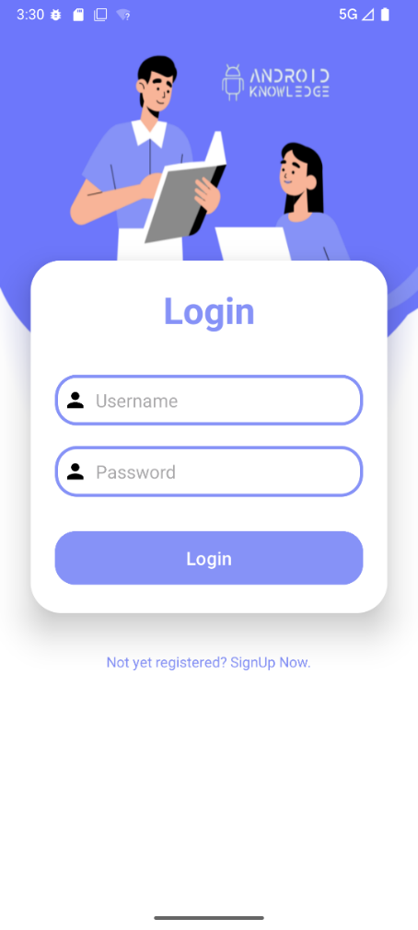 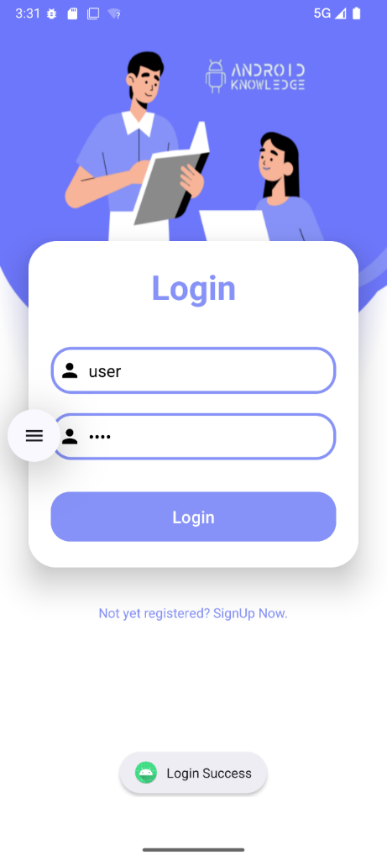

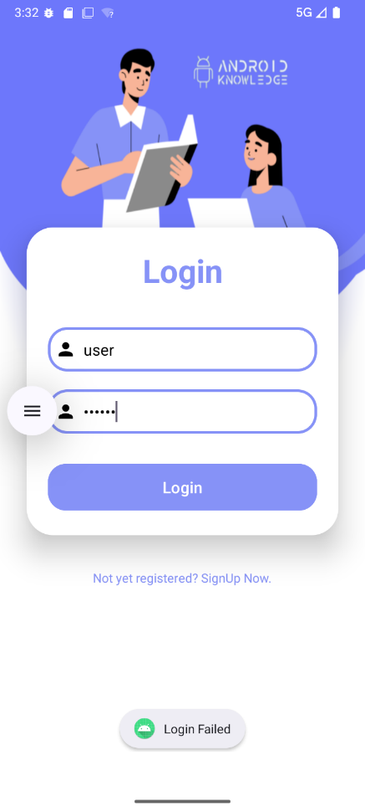

**Experiment 7: "** **Basic Number Addition “**

**Objective:** To learn how to get two numerical inputs from EditText fields and display their sum in a TextView on the screen.

**Question:** Design an Android screen where a user can type two numbers into two separate input boxes (EditText). Add a Button labeled "Add Numbers" and a TextView below it. When the "Add Numbers" button is clicked, add the two numbers typed by the user and display the total sum in the TextView on the screen.

**MainActivity.java**

package com.example.experiment7;

import android.os.Bundle;

import android.widget.Button;

import android.widget.EditText;

import android.widget.TextView;

import androidx.activity.EdgeToEdge;

import androidx.appcompat.app.AppCompatActivity;

import androidx.core.graphics.Insets;

import androidx.core.view.ViewCompat;

import androidx.core.view.WindowInsetsCompat;

public class MainActivity extends AppCompatActivity {

EditText editTextNumber1, editTextNumber2;

TextView textViewResult;

@Override

protected void onCreate(Bundle savedInstanceState) {

super.onCreate(savedInstanceState);

setContentView(R.layout.activity_main);

editTextNumber1 = findViewById(R.id.editTextNumber1);

editTextNumber2 = findViewById(R.id.editTextNumber2);

Button buttonAdd = findViewById(R.id.buttonAdd);

textViewResult = findViewById(R.id.textViewResult);

buttonAdd.setOnClickListener(view -> {

String num1Str = editTextNumber1.getText().toString().trim();

String num2Str = editTextNumber2.getText().toString().trim();

if (!num1Str.isEmpty() && !num2Str.isEmpty()) {

try {

int num1 = Integer.parseInt(num1Str);

int num2 = Integer.parseInt(num2Str);

int sum = num1 + num2;

textViewResult.setText("Sum: " + sum);

} catch (NumberFormatException e) {

textViewResult.setText("Invalid number format");

}

} else {

textViewResult.setText("Please enter both numbers");

}

});

}

}

**activity_main.xml**

<?xml version="1.0" encoding="utf-8"?>

<LinearLayout xmlns:android="http://schemas.android.com/apk/res/android"

android:layout_width="match_parent"

android:layout_height="match_parent"

android:orientation="vertical"

android:padding="24dp">

<EditText

android:id="@+id/editTextNumber1"

android:layout_width="match_parent"

android:layout_height="wrap_content"

android:hint="Enter first number"

android:inputType="number"

android:padding="12dp" />

<EditText

android:id="@+id/editTextNumber2"

android:layout_width="match_parent"

android:layout_height="wrap_content"

android:hint="Enter second number"

android:inputType="number"

android:padding="12dp"

android:layout_marginBottom="16dp" />

<Button

android:id="@+id/buttonAdd"

android:layout_width="match_parent"

android:layout_height="wrap_content"

android:text="Add Numbers" />

<TextView

android:id="@+id/textViewResult"

android:layout_width="match_parent"

android:layout_height="wrap_content"

android:textSize="18sp"

android:padding="12dp"

android:layout_marginTop="16dp" />

</LinearLayout>

**Output**

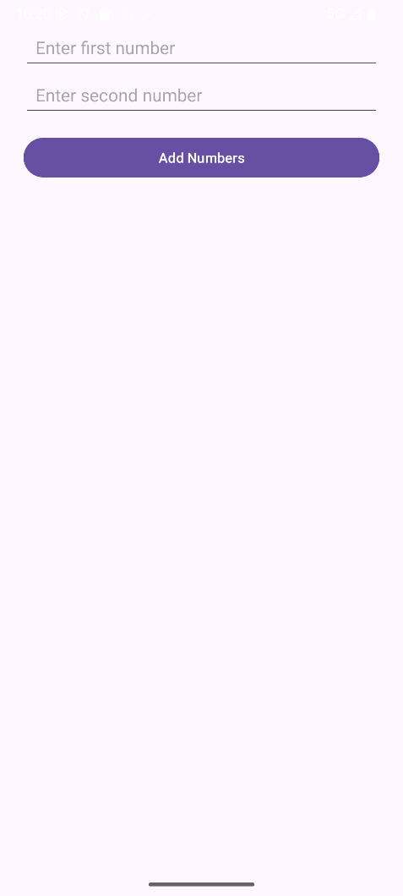 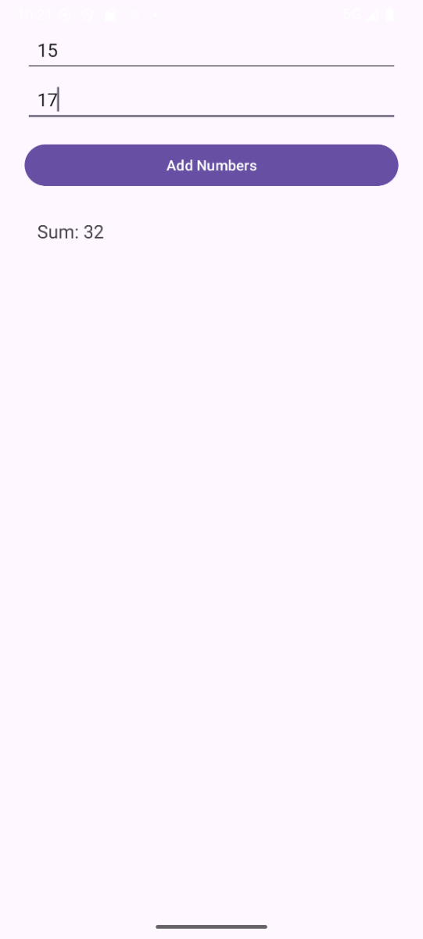

**Experiment 8: "** **Image Toggle “**

**Objective:** To learn how to use FrameLayout to stack UI elements and toggle their visibility.

**Question:** Develop an application that toggles an image using FrameLayout. When a button is clicked, make one image disappear and another appear in its place.

**MainActivity.java**

package com.example.experiment8;

import android.media.Image;

import android.os.Bundle;

import android.view.View;

import android.widget.Button;

import android.widget.ImageView;

import androidx.activity.EdgeToEdge;

import androidx.appcompat.app.AppCompatActivity;

import androidx.core.graphics.Insets;

import androidx.core.view.ViewCompat;

import androidx.core.view.WindowInsetsCompat;

public class MainActivity extends AppCompatActivity implements View.OnClickListener {

ImageView Img;

boolean flg;

@Override

protected void onCreate(Bundle savedInstanceState) {

super.onCreate(savedInstanceState);

EdgeToEdge.enable(this);

setContentView(R.layout.activity_main);

Button btn=(Button)findViewById(R.id.btn);

Img=(ImageView)findViewById(R.id.img);

btn.setOnClickListener((View.OnClickListener) this);

flg=true;

}

@Override

public void onClick(View view) {

if(flg){

Img.setImageResource(R.drawable.image1);

flg=false;

}

else{

Img.setImageResource(R.drawable.image2);

}

}

}

**activity_main.xml**

<?xml version="1.0" encoding="utf-8"?>

<LinearLayout xmlns:android="http://schemas.android.com/apk/res/android"

xmlns:app="http://schemas.android.com/apk/res-auto"

xmlns:tools="http://schemas.android.com/tools"

android:id="@+id/main"

android:layout_width="match_parent"

android:layout_height="match_parent"

android:orientation="vertical"

android:gravity="center"

tools:context=".MainActivity">

<ImageView

android:id="@+id/img"

android:layout_width="299dp"

android:layout_height="592dp"

android:src="@drawable/image1"

android:text="Hello World!" />

<Button

android:id="@+id/btn"

android:layout_width="wrap_content"

android:layout_height="42dp"

android:text="Change Image" />

</LinearLayout>

**Output**

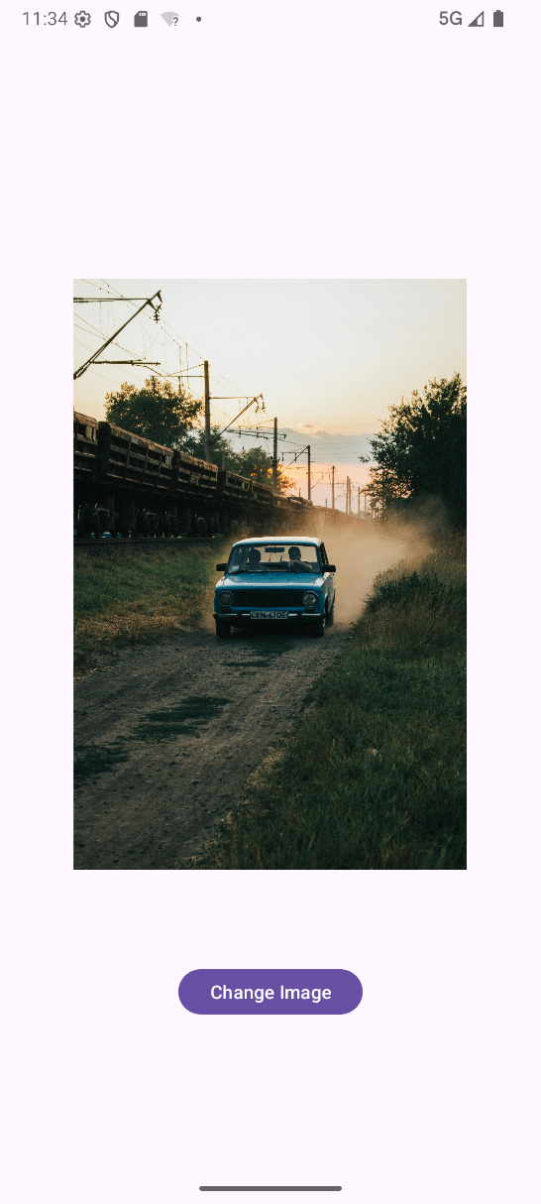 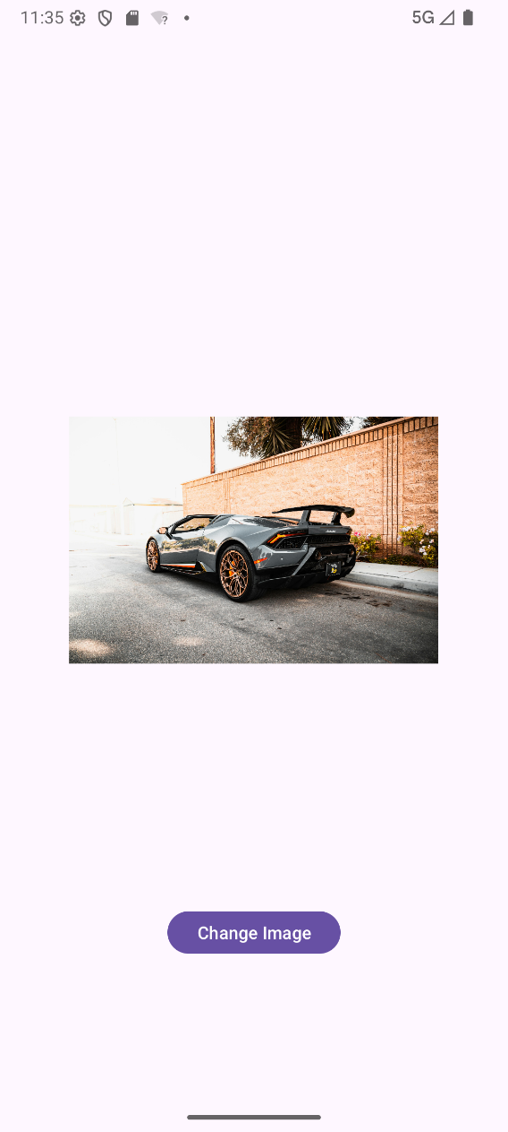

**Experiment 9: "** **Full-Featured Calculator with Layout Design “**

**Objective:** To learn how to build a complete, working calculator combining arithmetic logic with advanced layout techniques using GridLayout and LinearLayout.

**Question:** Build a complete calculator app. Design its entire screen using GridLayout for all the number buttons (0-9) and operation buttons (+, -, *, /, equals, clear). Use a LinearLayout for the display area at the top where numbers are typed and results are shown. Make sure the calculator can perform all basic math operations correctly, and displays the answers in the top display area.

**MainActivity.java**

package com.example.experiment9;

import android.os.Bundle;

import android.view.View;

import android.widget.Button;

import android.widget.EditText;

import androidx.activity.EdgeToEdge;

import androidx.appcompat.app.AppCompatActivity;

import androidx.core.graphics.Insets;

import androidx.core.view.ViewCompat;

import androidx.core.view.WindowInsetsCompat;

public class MainActivity extends AppCompatActivity {

EditText editText;

String oldNumber = "";

String operator = "";

boolean isNewOp = true;

@Override

protected void onCreate(Bundle savedInstanceState) {

super.onCreate(savedInstanceState);

EdgeToEdge.enable(this);

setContentView(R.layout.activity_main);

editText = findViewById(R.id.editText);

editText.setShowSoftInputOnFocus(false); // disables keyboard popup

}

// Handles all button clicks

public void operatorEvent(View view) {

Button btn = (Button) view;

String btnText = btn.getText().toString();

String number = editText.getText().toString();

switch (btnText) {

case "C":

editText.setText("0.0");

isNewOp = true;

oldNumber = "";

operator = "";

break;

case "+":

case "-":

case "*":

case "/":

oldNumber = number;

operator = btnText;

editText.setText(number + operator);

isNewOp = false;

break;

case "=":

String[] parts = number.split("[" + "\\+\\-\\*/" + "]");

if (parts.length < 2) return;

double first = Double.parseDouble(parts[0]);

double second = Double.parseDouble(parts[1]);

double result = 0.0;

switch (operator) {

case "+": result = first + second; break;

case "-": result = first - second; break;

case "*": result = first * second; break;

case "/":

if (second != 0) result = first / second;

else {

editText.setText("Error");

return;

}

break;

}

editText.setText(String.valueOf(result));

isNewOp = true;

break;

default: // digits

if (isNewOp || number.equals("0.0")) {

editText.setText(btnText);

isNewOp = false;

} else {

editText.setText(number + btnText);

}

break;

}

}

}

**activity_main.xml**

<?xml version="1.0" encoding="utf-8"?>

<LinearLayout

xmlns:android="http://schemas.android.com/apk/res/android"

xmlns:app="http://schemas.android.com/apk/res-auto"

xmlns:tools="http://schemas.android.com/tools"

android:layout_width="match_parent"

android:layout_height="match_parent"

android:orientation="vertical"

android:padding="10dp"

tools:context=".MainActivity">

<EditText

android:layout_width="match_parent"

android:layout_height="421dp"

android:id="@+id/editText"

android:layout_marginLeft="20dp"

android:layout_marginRight="20dp"

android:layout_marginTop="10dp"

android:layout_marginBottom="20dp"

android:layout_weight="1"

android:textColor="@color/orange"

android:ems="10"

android:layout_gravity="right|center"

android:text="0.0"

android:textSize="100dp"

android:inputType="number"/>

<GridLayout

android:layout_width="wrap_content"

android:layout_height="wrap_content"

android:rowCount="4"

android:columnCount="4"

android:layout_marginLeft="20dp"

android:layout_marginRight="20dp"

android:layout_marginBottom="10dp">

<Button

android:layout_width="35pt"

android:layout_height="50pt"

android:id="@+id/b1"

android:layout_marginRight="10dp"

android:layout_weight="1"

android:onClick="operatorEvent"

android:text="C"

android:textSize="40dp"

tools:ignore="OnClick" />

<Button

android:layout_width="35pt"

android:layout_height="50pt"

android:id="@+id/b2"

android:layout_marginRight="10dp"

android:layout_weight="1"

android:onClick="operatorEvent"

android:text="0"

android:textSize="40dp"

tools:ignore="OnClick" />

<Button

android:layout_width="35pt"

android:layout_height="50pt"

android:id="@+id/b3"

android:layout_marginRight="10dp"

android:layout_weight="1"

android:onClick="operatorEvent"

android:text="*"

android:textSize="40dp"

tools:ignore="OnClick" />

<Button

android:layout_width="35pt"

android:layout_height="50pt"

android:id="@+id/b4"

android:layout_marginRight="10dp"

android:layout_weight="1"

android:onClick="operatorEvent"

android:text="-"

android:textSize="40dp"

tools:ignore="OnClick" />

</GridLayout>

<GridLayout

android:layout_width="wrap_content"

android:layout_height="wrap_content"

android:rowCount="4"

android:columnCount="4"

android:layout_marginLeft="20dp"

android:layout_marginRight="20dp"

android:layout_marginBottom="10dp">

<Button

android:layout_width="35pt"

android:layout_height="50pt"

android:id="@+id/b5"

android:layout_marginRight="10dp"

android:layout_weight="1"

android:onClick="operatorEvent"

android:text="7"

android:textSize="40dp"

tools:ignore="OnClick" />

<Button

android:layout_width="35pt"

android:layout_height="50pt"

android:id="@+id/b6"

android:layout_marginRight="10dp"

android:layout_weight="1"

android:onClick="operatorEvent"

android:text="8"

android:textSize="40dp"

tools:ignore="OnClick" />

<Button

android:layout_width="35pt"

android:layout_height="50pt"

android:id="@+id/b7"

android:layout_marginRight="10dp"

android:layout_weight="1"

android:onClick="operatorEvent"

android:text="9"

android:textSize="40dp"

tools:ignore="OnClick" />

<Button

android:layout_width="35pt"

android:layout_height="50pt"

android:id="@+id/b8"

android:layout_marginRight="10dp"

android:layout_weight="1"

android:onClick="operatorEvent"

android:text="+"

android:textSize="40dp"

tools:ignore="OnClick" />

</GridLayout>

<GridLayout

android:layout_width="wrap_content"

android:layout_height="wrap_content"

android:rowCount="4"

android:columnCount="4"

android:layout_marginLeft="20dp"

android:layout_marginRight="20dp"

android:layout_marginBottom="10dp">

<Button

android:layout_width="35pt"

android:layout_height="50pt"

android:id="@+id/b9"

android:layout_marginRight="10dp"

android:layout_weight="1"

android:onClick="operatorEvent"

android:text="4"

android:textSize="40dp"

tools:ignore="OnClick" />

<Button

android:layout_width="35pt"

android:layout_height="50pt"

android:id="@+id/b10"

android:layout_marginRight="10dp"

android:layout_weight="1"

android:onClick="operatorEvent"

android:text="5"

android:textSize="40dp"

tools:ignore="OnClick" />

<Button

android:layout_width="35pt"

android:layout_height="50pt"

android:id="@+id/b11"

android:layout_marginRight="10dp"

android:layout_weight="1"

android:onClick="operatorEvent"

android:text="6"

android:textSize="40dp"

tools:ignore="OnClick" />

<Button

android:layout_width="35pt"

android:layout_height="50pt"

android:id="@+id/b12"

android:layout_marginRight="10dp"

android:layout_weight="1"

android:onClick="operatorEvent"

android:text="/"

android:textSize="40dp"

tools:ignore="OnClick" />

</GridLayout>

<GridLayout

android:layout_width="wrap_content"

android:layout_height="wrap_content"

android:rowCount="4"

android:columnCount="4"

android:layout_marginLeft="20dp"

android:layout_marginRight="20dp"

android:layout_marginBottom="10dp">

<Button

android:layout_width="35pt"

android:layout_height="50pt"

android:id="@+id/b13"

android:layout_marginRight="10dp"

android:layout_weight="1"

android:onClick="operatorEvent"

android:text="1"

android:textSize="40dp"

tools:ignore="OnClick" />

<Button

android:layout_width="35pt"

android:layout_height="50pt"

android:id="@+id/b14"

android:layout_marginRight="10dp"

android:layout_weight="1"

android:onClick="operatorEvent"

android:text="2"

android:textSize="40dp"

tools:ignore="OnClick" />

<Button

android:layout_width="35pt"

android:layout_height="50pt"

android:id="@+id/b15"

android:layout_marginRight="10dp"

android:layout_weight="1"

android:onClick="operatorEvent"

android:text="3"

android:textSize="40dp"

tools:ignore="OnClick" />

<Button

android:layout_width="35pt"

android:layout_height="50pt"

android:id="@+id/b16"

android:layout_marginRight="10dp"

android:layout_weight="1"

android:onClick="operatorEvent"

android:text="="

android:textSize="40dp"

tools:ignore="OnClick" />

</GridLayout>

</LinearLayout>

**Output**

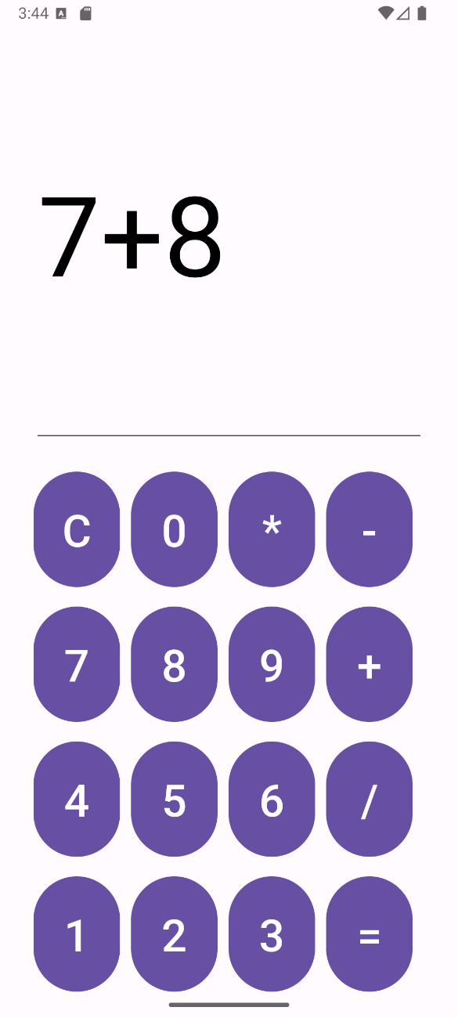 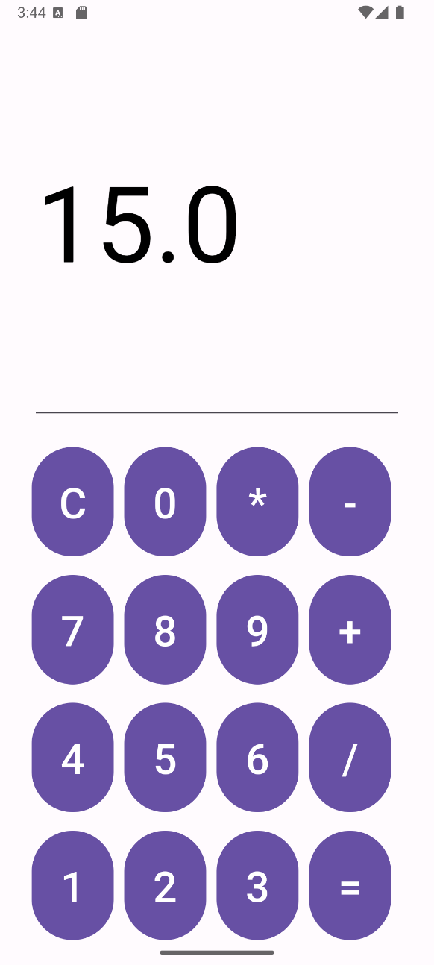

**Experiment 10: "** **Student Registration Form with Checks “**

**Objective:** Learn to build a form with different input fields and check if the information typed is correct.

**Question:** Design a student sign-up form. Include boxes for Name, Email, Password, and Phone Number. Add a "Register" button. When clicked, check if each box has corrected info (e.g., email has "@", phone is 10 digits, password isn't empty). If everything is good, show a message "Signed Up!". If something is wrong, show a message saying what needs fixing.

**MainActivity.java**

package com.example.experiment10;

import android.os.Bundle;

import android.view.View;

import android.widget.EditText;

import android.widget.Toast;

import androidx.activity.EdgeToEdge;

import androidx.appcompat.app.AppCompatActivity;

import androidx.core.graphics.Insets;

import androidx.core.view.ViewCompat;

import androidx.core.view.WindowInsetsCompat;

import com.google.android.material.button.MaterialButton;

public class MainActivity extends AppCompatActivity {

@Override

protected void onCreate(Bundle savedInstanceState) {

super.onCreate(savedInstanceState);

EdgeToEdge.enable(this);

setContentView(R.layout.activity_main);

// 1. Initialize all EditText and Button views

EditText username = findViewById(R.id.username);

EditText useremail = findViewById(R.id.useremail);

EditText phoneNumber = findViewById(R.id.phonenumber);

EditText password = findViewById(R.id.password);

// Based on your XML, cpassword is the fourth EditText, so we'll assume it's for the phone number.

MaterialButton regbtn = findViewById(R.id.signupbtn);

// 2. Set an OnClickListener for the registration button

regbtn.setOnClickListener(new View.OnClickListener() {

@Override

public void onClick(View view) {

// 3. Get the text from each input field and trim whitespace

String name = username.getText().toString().trim();

String email = useremail.getText().toString().trim();

String phone = phoneNumber.getText().toString().trim();

String pass = password.getText().toString().trim();

// 4. Perform validation checks

if (name.isEmpty()) {

Toast.makeText(MainActivity.this,"Name cannot be empty.", Toast.LENGTH_SHORT).show();

} else if (!email.contains("@")) {

Toast.makeText(MainActivity.this, "Please enter a valid email address.", Toast.LENGTH_SHORT).show();

} else if (phone.length() != 10) {

Toast.makeText(MainActivity.this, "Phone number must be 10 digits.", Toast.LENGTH_SHORT).show();

} else if (pass.isEmpty()) {

Toast.makeText(MainActivity.this, "Password cannot be empty.", Toast.LENGTH_SHORT).show();

} else {

// 5. If all validations pass, show a success message

Toast.makeText(MainActivity.this, "Signed Up! Welcome, " + name + ".", Toast.LENGTH_LONG).show();

}

}

});

}

}

**activity_main.xml**

<?xml version="1.0" encoding="utf-8"?>

<RelativeLayout

xmlns:android="http://schemas.android.com/apk/res/android"

xmlns:app="http://schemas.android.com/apk/res-auto"

xmlns:tools="http://schemas.android.com/tools"

android:id="@+id/main"

android:layout_width="match_parent"

android:layout_height="match_parent"

android:background="@drawable/rbgg"

tools:context=".MainActivity">

<TextView

android:id="@+id/signuptitle"

android:layout_width="match_parent"

android:layout_height="wrap_content"

android:layout_margin="25dp"

android:layout_marginTop="25dp"

android:layout_marginBottom="25dp"

android:gravity="center"

android:text="Sign-Up"

android:textColor="@color/black"

android:textSize="35dp"

android:textStyle="bold" />

<EditText

android:layout_width="match_parent"

android:layout_height="wrap_content"

android:id="@+id/username"

android:layout_below="@+id/signuptitle"

android:background="#30ffffff"

android:hint="Username"

android:textColorHint="@color/white"

android:textColor="@color/white"

android:layout_margin="10dp"

android:padding="20dp"/>

<EditText

android:layout_width="match_parent"

android:layout_height="wrap_content"

android:id="@+id/useremail"

android:layout_below="@+id/username"

android:background="#30ffffff"

android:hint="Email"

android:textColorHint="@color/white"

android:textColor="@color/white"

android:layout_margin="10dp"

android:padding="20dp"/>

<EditText

android:id="@+id/phonenumber"

android:layout_width="match_parent"

android:layout_height="wrap_content"

android:layout_below="@+id/useremail"

android:layout_margin="10dp"

android:layout_marginTop="129dp"

android:layout_marginBottom="10dp"

android:background="#30ffffff"

android:hint="Phone Number"

android:padding="20dp"

android:textColor="@color/white"

android:textColorHint="@color/white" />

<EditText

android:layout_width="match_parent"

android:layout_height="wrap_content"

android:id="@+id/password"

android:layout_below="@+id/phonenumber"

android:background="#30ffffff"

android:hint="Password"

android:textColorHint="@color/white"

android:textColor="@color/white"

android:layout_margin="10dp"

android:padding="20dp"/>

<com.google.android.material.button.MaterialButton

android:layout_width="wrap_content"

android:layout_height="wrap_content"

android:id="@+id/signupbtn"

android:text="Sign-Up"

android:textSize="25dp"

android:layout_below="@+id/password"

android:layout_centerHorizontal="true"

android:backgroundTint="@color/design_default_color_secondary"

android:layout_margin="20dp"/>

<TextView

android:layout_width="wrap_content"

android:layout_height="wrap_content"

android:id="@+id/info"

android:text="or signup with"

android:textSize="25dp"

android:textColor="@color/black"

android:layout_below="@+id/signupbtn"

android:layout_centerHorizontal="true"/>

<LinearLayout

android:layout_width="match_parent"

android:layout_height="wrap_content"

android:id="@+id/socialicons"

android:gravity="center"

android:layout_below="@+id/info"

android:layout_alignParentBottom="true">

<ImageView

android:layout_width="48dp"

android:layout_height="48dp"

android:layout_margin="20dp"

android:src="@drawable/googleicon"/>

<ImageView

android:layout_width="48dp"

android:layout_height="48dp"

android:layout_margin="20dp"

android:src="@drawable/facebookicon"/>

</LinearLayout>

</RelativeLayout>

**Output**

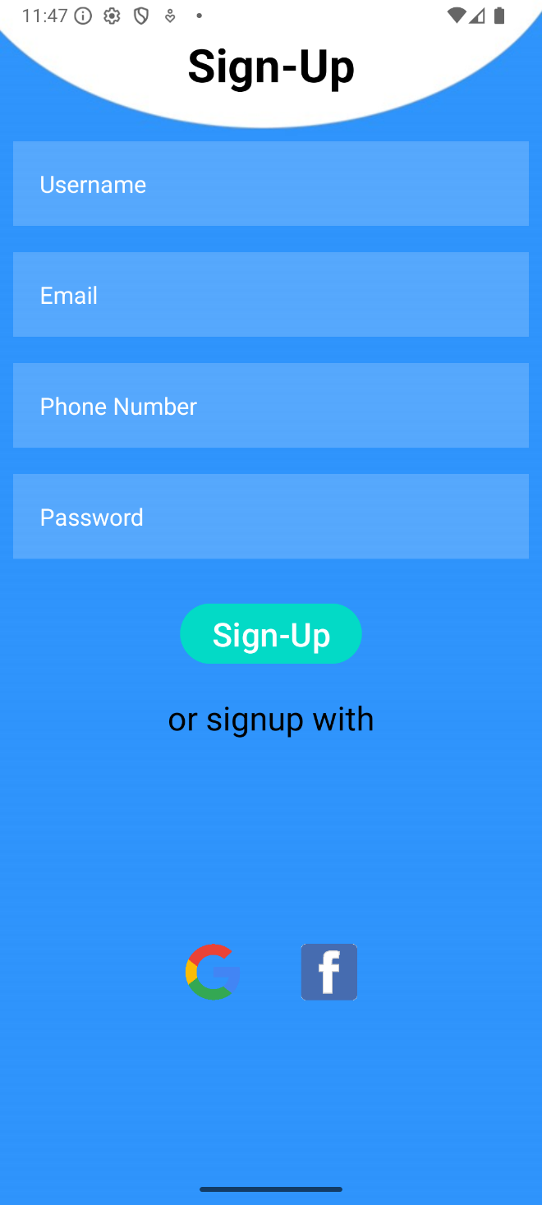 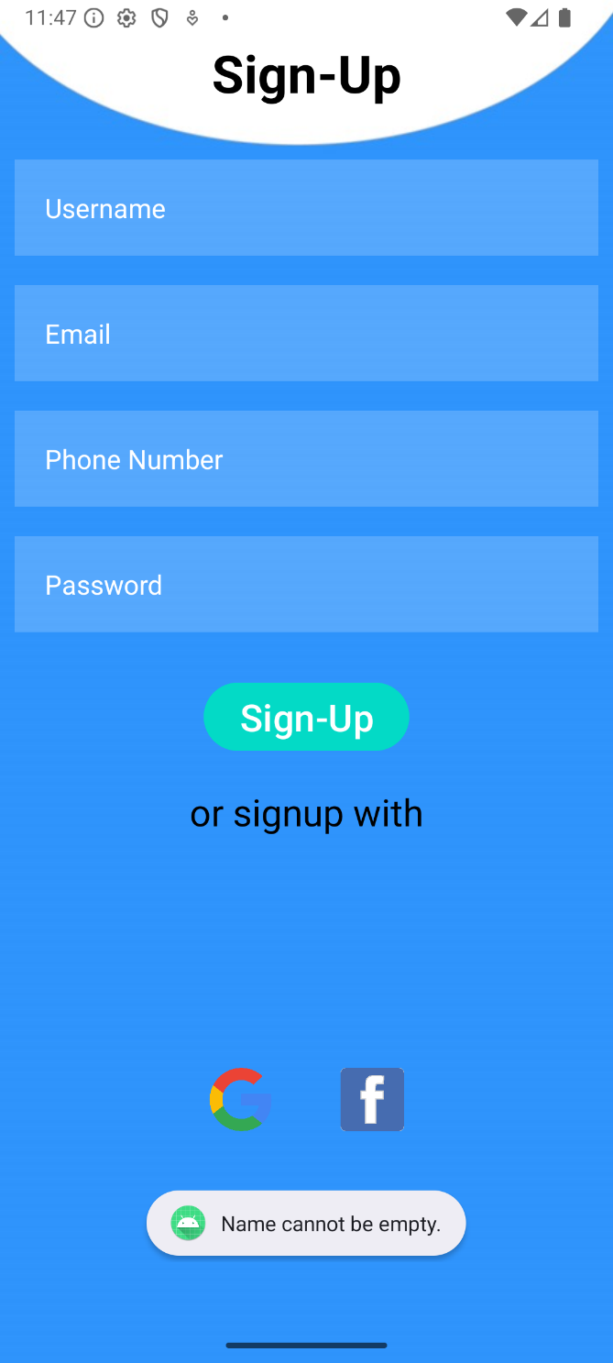

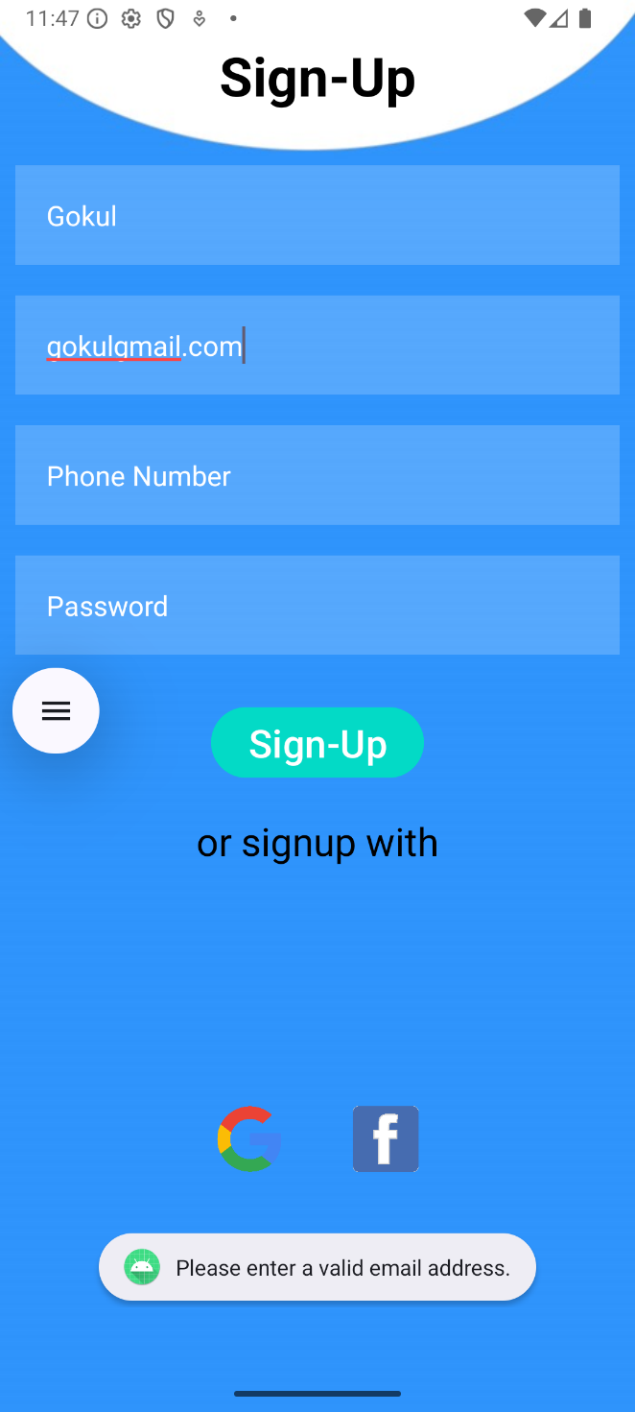 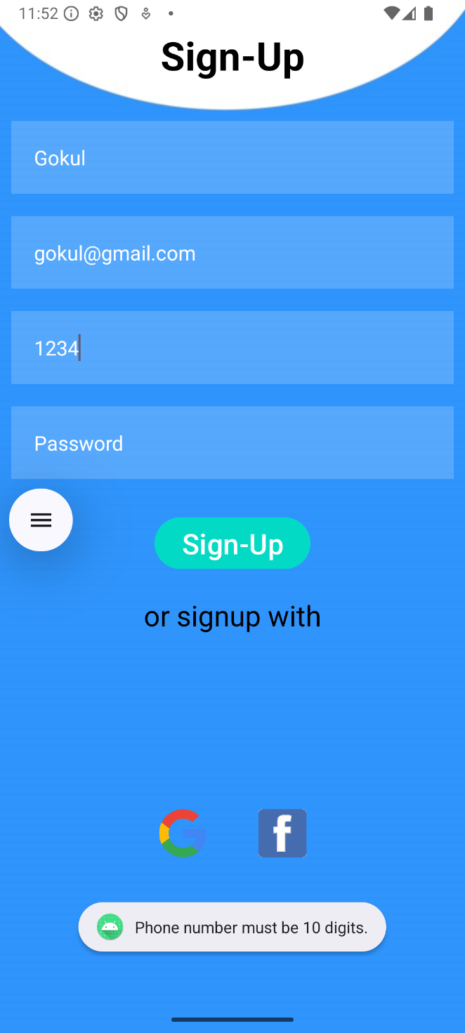

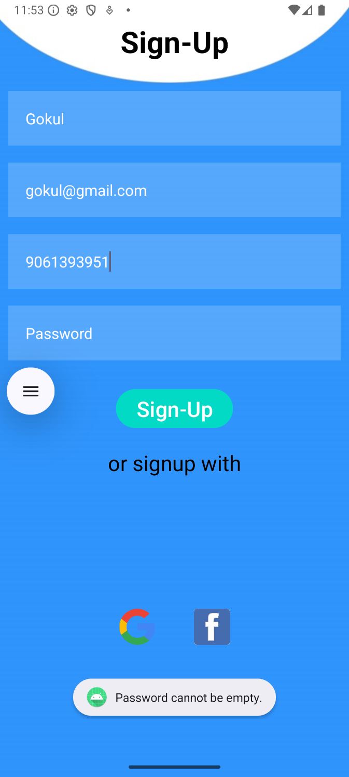 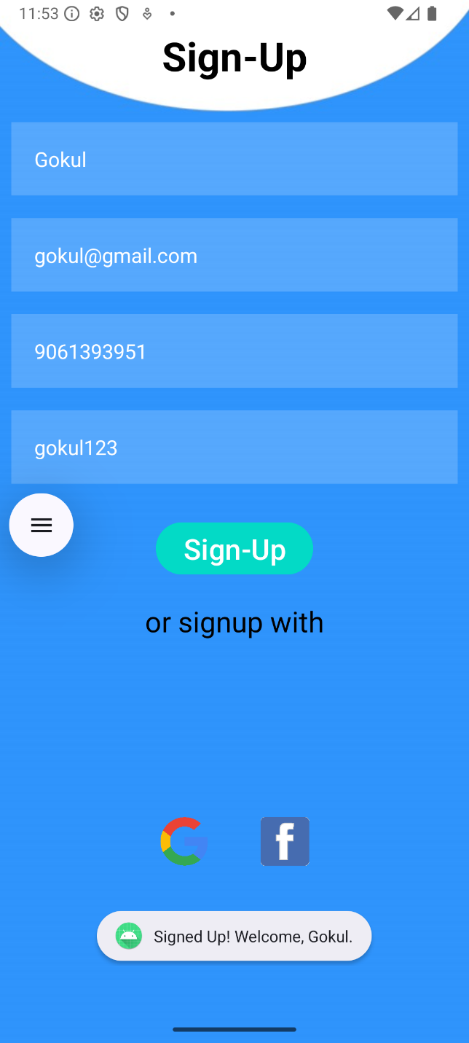

**Experiment 11: "Interest Selection Profile Page"**

**Objective**: Learn to use CheckBox for multiple selections and ListView to display selected items dynamically in a profile settings layout.

**Question**:Design a profile settings page for a user. Add several CheckBoxes with options like "Music", "Sports", "Travel", "Movies", etc., representing the user's interests. Below the CheckBoxes, add a "Submit" button. When the button is clicked, display the selected interests in a TextView  below.

**MainActivity.java**

package com.example.experiment11;

import android.os.Bundle;

import android.widget.Button;

import android.widget.CheckBox;

import android.widget.TextView;

import androidx.activity.EdgeToEdge;

import androidx.appcompat.app.AppCompatActivity;

import androidx.core.graphics.Insets;

import androidx.core.view.ViewCompat;

import androidx.core.view.WindowInsetsCompat;

public class MainActivity extends AppCompatActivity {

CheckBox cbMusic, cbSports, cbTravel, cbMovies, cbReading;

Button btnSubmit;

TextView tvResult;

@Override

protected void onCreate(Bundle savedInstanceState) {

super.onCreate(savedInstanceState);

setContentView(R.layout.activity_main);

cbMusic = findViewById(R.id.cbMusic);

cbSports = findViewById(R.id.cbSports);

cbTravel = findViewById(R.id.cbTravel);

cbMovies = findViewById(R.id.cbMovies);

cbReading = findViewById(R.id.cbReading);

btnSubmit = findViewById(R.id.btnSubmit);

tvResult = findViewById(R.id.tvResult);

btnSubmit.setOnClickListener(v -> {

StringBuilder selected = new StringBuilder("Your Interests: "); if (cbMusic.isChecked()) selected.append("Music, ");

if (cbSports.isChecked()) selected.append("Sports, ");

if (cbTravel.isChecked()) selected.append("Travel, ");

if (cbMovies.isChecked()) selected.append("Movies, ");

if (cbReading.isChecked()) selected.append("Reading, ");

if (selected.toString().equals("Your Interests: ")) {

tvResult.setText("No interests selected.");

} else {

selected.setLength(selected.length() - 2);

tvResult.setText(selected.toString());

}

});

}

}

**activity_main.xml**

<?xml version="1.0" encoding="utf-8"?>

<ScrollView xmlns:android="http://schemas.android.com/apk/res/android" android:layout_width="match_parent"

android:layout_height="match_parent">

<LinearLayout

android:layout_width="match_parent"

android:layout_height="wrap_content"

android:orientation="vertical"

android:padding="24dp">

<TextView

android:id="@+id/tvTitle"

android:layout_width="match_parent"

android:layout_height="wrap_content"

android:text="Select Your Interests"

android:textSize="20sp"

android:textStyle="bold"

android:gravity="center"

android:layout_marginBottom="16dp" />

<CheckBox

android:id="@+id/cbMusic"

android:layout_width="wrap_content"

android:layout_height="wrap_content"

android:text="Music" />

<CheckBox

android:id="@+id/cbSports"

android:layout_width="wrap_content"

android:layout_height="wrap_content"

android:text="Sports" />

<CheckBox

android:id="@+id/cbTravel"

android:layout_width="wrap_content"

android:layout_height="wrap_content"

android:text="Travel" />

<CheckBox

android:id="@+id/cbMovies"

android:layout_width="wrap_content"

android:layout_height="wrap_content"

android:text="Movies" />

<CheckBox

android:id="@+id/cbReading"

android:layout_width="wrap_content"

android:layout_height="wrap_content"

android:text="Reading" />

<Button

android:id="@+id/btnSubmit"

android:layout_width="wrap_content"

android:layout_height="wrap_content"

android:text="Submit"/>

<TextView

android:id="@+id/tvResult"

android:layout_width="match_parent"

android:layout_height="wrap_content"

android:textSize="16sp"

android:layout_marginTop="24dp"

android:textStyle="italic"

android:text="Your selected interests will appear here." /> </LinearLayout>

</ScrollView>

**Output**

 

**Experiment 12: "Image Slider with Button Clicks"**

**Objective** : Learn to switch between multiple images (more than two) using FrameLayout  and control their visibility using Next/Previous buttons.

**Question**: Design an Android app that displays one image at a time using a FrameLayout.  Place at least inside the layout, one on top of the other. Add two buttons: and . When the  user clicks , show the next image; clicking shows the previous image. The images should  loop correctly from last to first and vice versa.

**MainActivity.java**

package com.example.experiment12;

import android.os.Bundle;

import android.view.View;

import android.widget.Button;

import android.widget.ImageView;

import androidx.activity.EdgeToEdge;

import androidx.appcompat.app.AppCompatActivity;

import androidx.core.graphics.Insets;

import androidx.core.view.ViewCompat;

import androidx.core.view.WindowInsetsCompat;

public class MainActivity extends AppCompatActivity {

private ImageView[] images;

private int current = 0; // Index of currently visible image

@Override

protected void onCreate(Bundle savedInstanceState) {

super.onCreate(savedInstanceState);

setContentView(R.layout.activity_main);

images = new ImageView[]{

findViewById(R.id.image1),

findViewById(R.id.image2),

findViewById(R.id.image3)

// Add more if you have more images

};

Button nextBtn = findViewById(R.id.btnNext);

Button prevBtn = findViewById(R.id.btnPrev);

nextBtn.setOnClickListener(new View.OnClickListener() {

@Override

public void onClick(View v) {

images[current].setVisibility(View.GONE);

current = (current + 1) % images.length;

images[current].setVisibility(View.VISIBLE);

}

});

prevBtn.setOnClickListener(new View.OnClickListener() {

@Override

public void onClick(View v) {

images[current].setVisibility(View.GONE);

current = (current - 1 + images.length) % images.length;

images[current].setVisibility(View.VISIBLE);

}

});

}

}

**activity_main.xml**

<?xml version="1.0" encoding="utf-8"?>

<LinearLayout xmlns:android="http://schemas.android.com/apk/res/android" android:layout_width="match_parent"

android:layout_height="match_parent"

android:orientation="vertical"

android:gravity="center"

android:padding="16dp">

<!-- Image container -->

<FrameLayout

android:id="@+id/frameLayout"

android:layout_width="250dp"

android:layout_height="250dp">

<ImageView

android:id="@+id/image1"

android:layout_width="match_parent"

android:layout_height="match_parent"

android:src="@drawable/img1"

android:scaleType="centerCrop"

android:visibility="visible" />

<ImageView

android:id="@+id/image2"

android:layout_width="match_parent"

android:layout_height="match_parent"

android:src="@drawable/img2"

android:scaleType="centerCrop"

android:visibility="gone" />

<ImageView

android:id="@+id/image3"

android:layout_width="match_parent"

android:layout_height="match_parent"

android:src="@drawable/img3"

android:scaleType="centerCrop"

android:visibility="gone" />

</FrameLayout>

<LinearLayout

android:layout_width="wrap_content"

android:layout_height="wrap_content"

android:orientation="horizontal"

android:layout_marginTop="20dp">

<Button

android:id="@+id/btnPrev"

android:layout_width="wrap_content"

android:layout_height="wrap_content"

android:text="Previous" />

<Button

android:id="@+id/btnNext"

android:layout_width="wrap_content"

android:layout_height="wrap_content"

android:text="Next"

android:layout_marginStart="20dp" />

</LinearLayout>

</LinearLayout>

**Output**

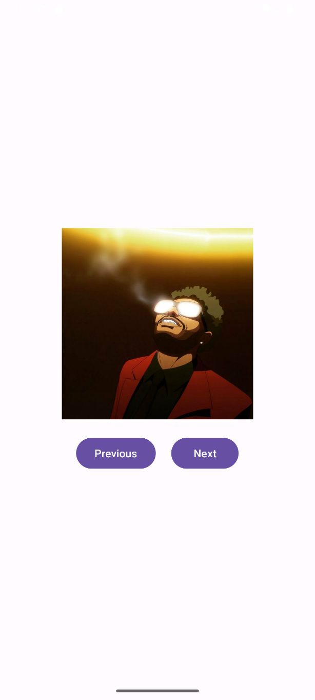 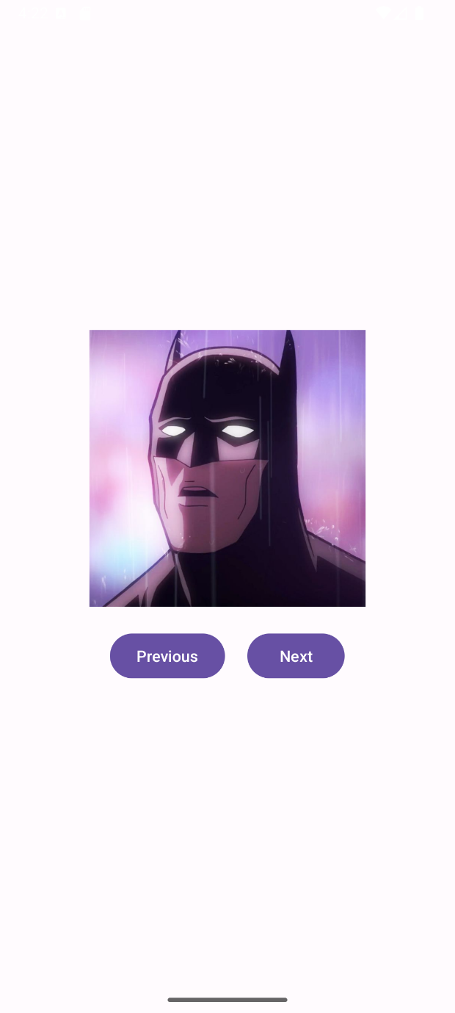

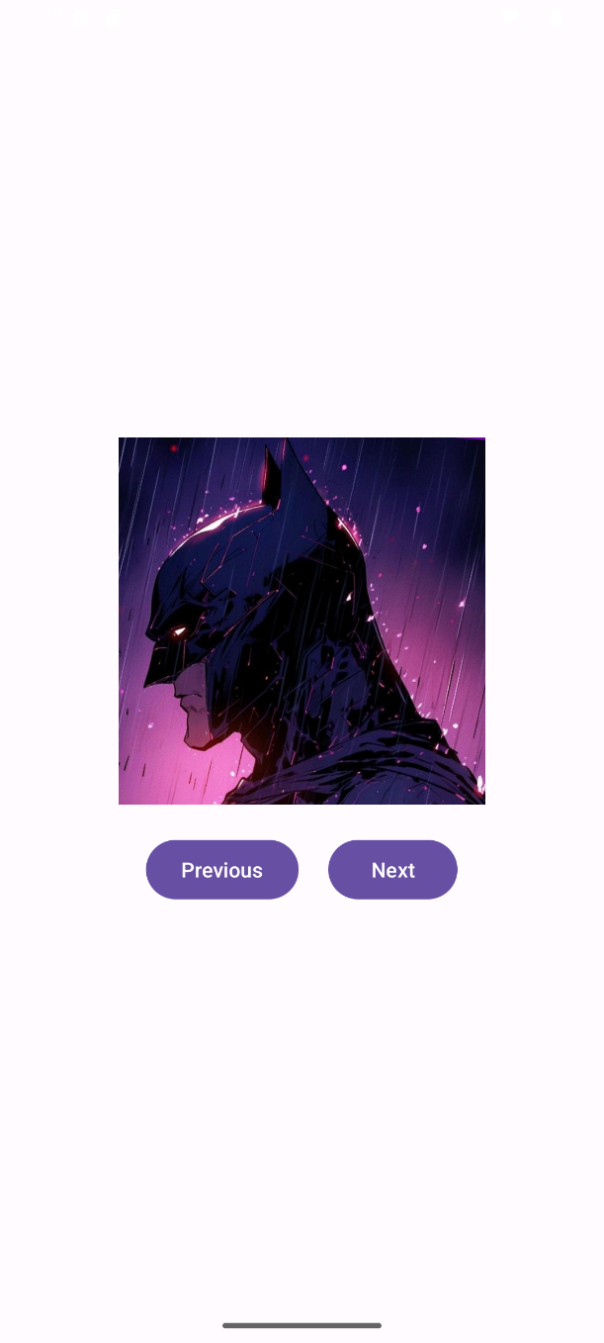 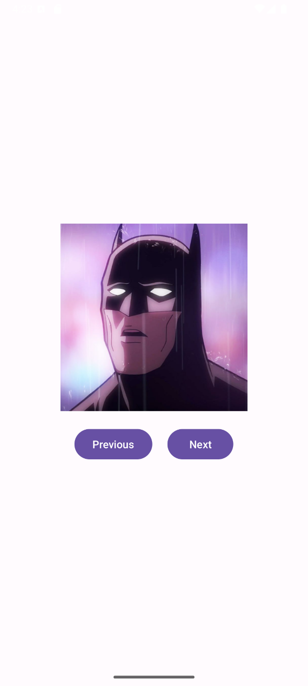

**Experiment 13: "Colour Picker with ListView"**

**Objective**: Learn to change the background color of an app's screen based on user  selection from a ListView (ListBox).

**Question**: Create an app with a main screen that serves as the background. Add a  ListView (ListBox) displaying at least three color options — for example: Red, Green, and  Blue. When the user taps on a color from the list, change the background color of the  screen to the selected color.

**MainActivity.java**

package com.example.experiment13;

import android.annotation.SuppressLint;

import android.graphics.Color;

import android.os.Bundle;

import android.widget.ArrayAdapter;

import android.widget.LinearLayout;

import android.widget.ListView;

import androidx.activity.EdgeToEdge;

import androidx.appcompat.app.AppCompatActivity;

import androidx.core.graphics.Insets;

import androidx.core.view.ViewCompat;

import androidx.core.view.WindowInsetsCompat;

public class MainActivity extends AppCompatActivity {

private LinearLayout mainLayout;

private ListView colorList;

private String[] colors = {"Red", "Green", "Blue"};

@SuppressLint("MissingInflatedId")

@Override

protected void onCreate(Bundle savedInstanceState) {

super.onCreate(savedInstanceState);

setContentView(R.layout.activity_main);

mainLayout = findViewById(R.id.mainLayout);

colorList = findViewById(R.id.colorList);

ArrayAdapter<String> adapter = new ArrayAdapter<>(this,

android.R.layout.simple_list_item_1, colors);

colorList.setAdapter(adapter);

colorList.setOnItemClickListener((parent, view, position, id) -> {

switch (colors[position]) {

case "Red":

mainLayout.setBackgroundColor(Color.RED);

break;

case "Green":

mainLayout.setBackgroundColor(Color.GREEN);

break;

case "Blue":

mainLayout.setBackgroundColor(Color.BLUE);

break;

}

});

}

}

**activity_main.xml**

<?xml version="1.0" encoding="utf-8"?>

<LinearLayout xmlns:android="http://schemas.android.com/apk/res/android"

android:id="@+id/mainLayout"

android:layout_width="match_parent"

android:layout_height="match_parent"

android:orientation="vertical"

android:padding="24dp">

<TextView

android:id="@+id/title"

android:layout_width="wrap_content"

android:layout_height="wrap_content"

android:text="Choose a Color"

android:textSize="20sp"

android:textStyle="bold"

android:layout_marginBottom="16dp" />

<ListView

android:id="@+id/colorList"

android:layout_width="match_parent"

android:layout_height="wrap_content"

android:dividerHeight="2dp" />

</LinearLayout>

**Output**

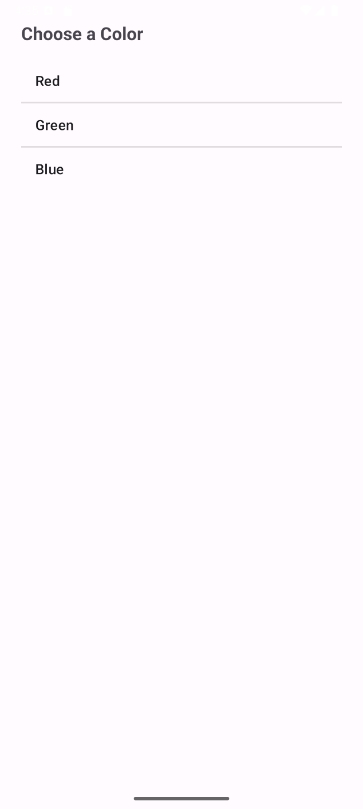 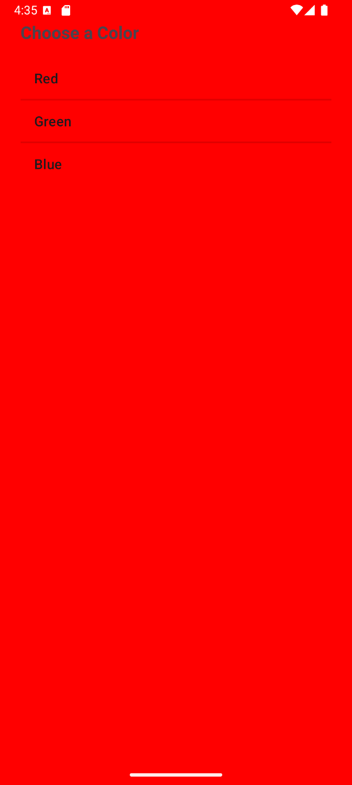

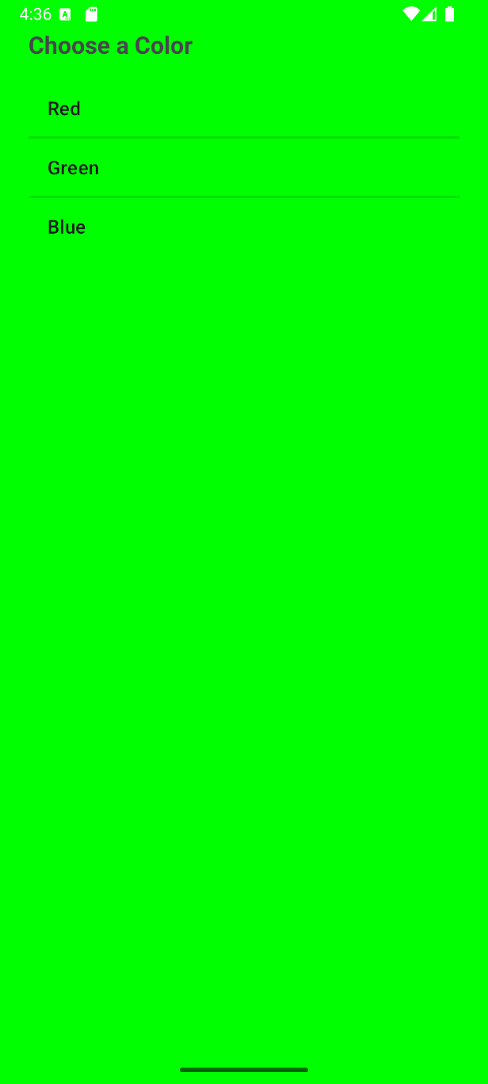 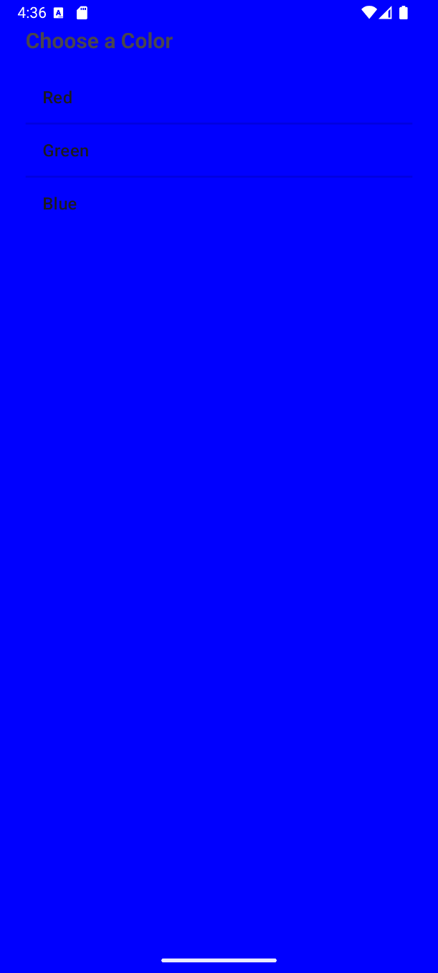

**CO4: Intents, menus, inter-component navigation**

**Experiment 14: "Multi-Activity Navigation”**

**Objective:** To learn how to navigate between different activities (screens) in an application using Intents.

**Question:** Implement Intents to navigate between multiple activities in login application.

**MainActivity.java**

package com.example.experiment14;

import android.annotation.SuppressLint;

import android.content.Intent;

import android.os.Bundle;

import android.view.View;

import android.widget.Button;

import android.widget.EditText;

import android.widget.Toast;

import androidx.appcompat.app.AppCompatActivity;

public class MainActivity extends AppCompatActivity {

EditText username;

EditText password;

Button loginButton;

@SuppressLint("MissingInflatedId")

@Override

protected void onCreate(Bundle savedInstanceState) {

super.onCreate(savedInstanceState);

setContentView(R.layout.activity_main);

username=findViewById(R.id.username);

password=findViewById(R.id.password);

loginButton=findViewById(R.id.loginButton);

loginButton.setOnClickListener(new View.OnClickListener() {

@Override

public void onClick(View view) {

if(username.getText().toString().equals("user")&&

password.getText().toString().equals("1234"))

{

Intent intent = new Intent(MainActivity.this, MainActivity2.class);

startActivity(intent);

}

else {

Toast.makeText(MainActivity.this,"Login Failed",Toast.LENGTH_SHORT).show();

}

}

});

}

}

**activity_main.xml**

<?xml version="1.0" encoding="utf-8"?>

<LinearLayout

xmlns:android="http://schemas.android.com/apk/res/android"

xmlns:app="http://schemas.android.com/apk/res-auto"

xmlns:tools="http://schemas.android.com/tools"

xmlns:card_view="http://schemas.android.com/apk/res-auto"

android:id="@+id/main"

android:layout_width="match_parent"

android:layout_height="match_parent"

android:orientation="vertical"

android:gravity="center"

android:background="@drawable/lbg"

tools:context=".MainActivity">

<androidx.cardview.widget.CardView

android:layout_width="match_parent"

android:layout_height="wrap_content"

android:layout_margin="30dp"

app:cardCornerRadius="30dp"

app:cardElevation="20dp"

android:background="@drawable/custom_edittext">

<LinearLayout

android:layout_width="match_parent"

android:layout_height="wrap_content"

android:orientation="vertical"

android:layout_gravity="center_horizontal"

android:padding="24dp">

<TextView

android:layout_width="match_parent"

android:layout_height="wrap_content"

android:text="Login"

android:id="@+id/logintext"

android:textSize="36sp"

android:textAlignment="center"

android:textStyle="bold"

android:textColor="@color/black"/>

<EditText

android:layout_width="match_parent"

android:layout_height="50dp"

android:id="@+id/username"

android:background="@drawable/custom_edittext"

android:drawablePadding="8dp"

android:hint="Username"

android:padding="8dp"

android:textColor="@color/black"

android:textColorHighlight="@color/cardview_dark_background"

android:layout_marginTop="40dp"/>

<EditText

android:layout_width="match_parent"

android:layout_height="50dp"

android:id="@+id/password"

android:background="@drawable/custom_edittext"

android:drawablePadding="8dp"

android:hint="Password"

android:padding="8dp"

android:inputType="textPassword"

android:textColor="@color/black"

android:textColorHighlight="@color/cardview_dark_background"

android:layout_marginTop="20dp"/>

<Button

android:layout_width="match_parent"

android:layout_height="60dp"

android:id="@+id/loginButton"

android:text="Login"

android:textSize="18sp"

android:layout_marginTop="30dp"

android:backgroundTint="@color/black"

app:cornerRadius="20dp"/>

</LinearLayout>

</androidx.cardview.widget.CardView>

<TextView

android:layout_width="wrap_content"

android:layout_height="wrap_content"

android:padding="8dp"

android:text="Not yet registered? SignUp Now."

android:textSize="14sp"

android:textAlignment="center"

android:id="@+id/signupText"

android:textColor="@color/purple"

android:layout_marginBottom="20dp"/>

</LinearLayout>

**MainActivity2.java**

package com.example.experiment14;

import android.os.Bundle;

import androidx.appcompat.app.AppCompatActivity;

public class MainActivity2 extends AppCompatActivity {

@Override

protected void onCreate(Bundle savedInstanceState) {

super.onCreate(savedInstanceState);

setContentView(R.layout.activity_main2); // Home screen layout

}

}

**activity_main2.xml**

<!-- res/layout/activity_main2.xml -->

<LinearLayout xmlns:android="http://schemas.android.com/apk/res/android"

android:layout_width="match_parent"

android:layout_height="match_parent"

android:gravity="center"

android:orientation="vertical">

<TextView

android:id="@+id/tvWelcome"

android:text="Welcome to Home Screen!"

android:textSize="24sp"

android:layout_width="wrap_content"

android:layout_height="wrap_content" />

</LinearLayout>

**AndroidManifest.xml**

<?xml version="1.0" encoding="utf-8"?>

<manifest xmlns:android="http://schemas.android.com/apk/res/android"

xmlns:tools="http://schemas.android.com/tools">

<application

android:allowBackup="true"

android:dataExtractionRules="@xml/data_extraction_rules"

android:fullBackupContent="@xml/backup_rules"

android:icon="@mipmap/ic_launcher"

android:label="@string/app_name"

android:roundIcon="@mipmap/ic_launcher_round"

android:supportsRtl="true"

android:theme="@style/Theme.Experiment14">

<!-- Second Activity (MainActivity2) -->

<activity android:name=".MainActivity2" />

<!-- Main / Launcher Activity -->

<activity

android:name=".MainActivity"

android:exported="true">

<intent-filter>

<action android:name="android.intent.action.MAIN" />

<category android:name="android.intent.category.LAUNCHER" />

</intent-filter>

</activity>

</application>

</manifest>

**Output**

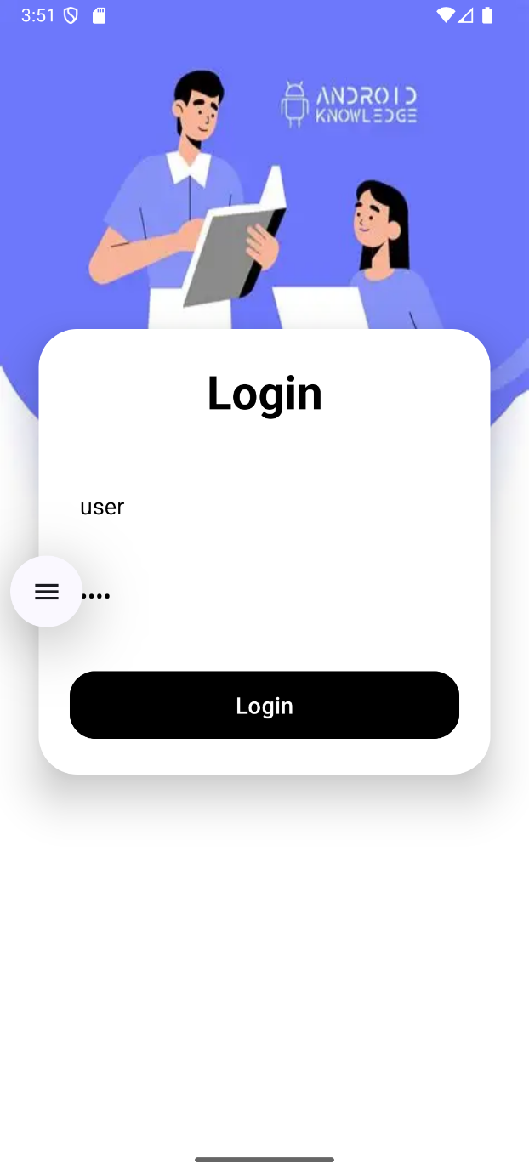 

**Experiment 15: "Options Menu Navigation"**

**Objective:** To learn how to implement an Options Menu and use it to navigate to different activities.

**Question:** Implement an Options Menu in your application. Use the menu items to navigate to different activities.

**MainActivity.java**

package com.example.experiment15;

import android.content.Intent;

import android.os.Bundle;

import android.view.Menu;

import android.view.MenuInflater;

import android.view.MenuItem;

import androidx.appcompat.app.AppCompatActivity;

import androidx.appcompat.widget.Toolbar;

public class MainActivity extends AppCompatActivity {

@Override

protected void onCreate(Bundle savedInstanceState) {

super.onCreate(savedInstanceState);

setContentView(R.layout.activity_main);

Toolbar toolbar = findViewById(R.id.toolbar);

setSupportActionBar(toolbar);

}

@Override

public boolean onCreateOptionsMenu(Menu menu) {

MenuInflater inflater = getMenuInflater();

inflater.inflate(R.menu.options_menu, menu);

return true;

}

@Override

public boolean onOptionsItemSelected(MenuItem item) {

int id = item.getItemId();

if (id == R.id.menu_first) {

startActivity(new Intent(this, FirstActivity.class));

return true;

} else if (id == R.id.menu_second) {

startActivity(new Intent(this, SecondActivity.class));

return true;

}

return super.onOptionsItemSelected(item);

}

}

**FirstActivity.java**

package com.example.experiment15;

import android.os.Bundle;

import androidx.appcompat.app.AppCompatActivity;

public class FirstActivity extends AppCompatActivity {

@Override

protected void onCreate(Bundle savedInstanceState) {

super.onCreate(savedInstanceState);

setContentView(R.layout.activity_first);

}

}

**SecondActivity.java**

package com.example.experiment15;

import android.os.Bundle;

import androidx.appcompat.app.AppCompatActivity;

public class SecondActivity extends AppCompatActivity {

@Override

protected void onCreate(Bundle savedInstanceState) {

super.onCreate(savedInstanceState);

setContentView(R.layout.activity_second);

}

}

**activity_main.xml**

<?xml version="1.0" encoding="utf-8"?>

<LinearLayout xmlns:android="http://schemas.android.com/apk/res/android"

xmlns:app="http://schemas.android.com/apk/res-auto"

android:layout_width="match_parent"

android:layout_height="match_parent"

android:orientation="vertical">

<androidx.appcompat.widget.Toolbar

android:id="@+id/toolbar"

android:layout_width="match_parent"

android:layout_height="?attr/actionBarSize"

android:background="?attr/colorPrimary"

app:title="Main Page"

android:theme="@style/ThemeOverlay.AppCompat.Dark.ActionBar"

app:popupTheme="@style/PopupMenuOverlayBlack" />

</LinearLayout>

**activity_first.xml**

<?xml version="1.0" encoding="utf-8"?>

<LinearLayout xmlns:android="http://schemas.android.com/apk/res/android"

android:layout_width="match_parent"

android:layout_height="match_parent"

android:gravity="center"

android:orientation="vertical">

<TextView

android:id="@+id/textFirst"

android:text="This is First Activity"

android:textSize="24sp"

android:layout_width="wrap_content"

android:layout_height="wrap_content" />

</LinearLayout>

**activity_second.xml**

<?xml version="1.0" encoding="utf-8"?>

<LinearLayout xmlns:android="http://schemas.android.com/apk/res/android"

android:layout_width="match_parent"

android:layout_height="match_parent"

android:gravity="center"

android:orientation="vertical">

<TextView

android:id="@+id/textSecond"

android:text="This is Second Activity"

android:textSize="24sp"

android:layout_width="wrap_content"

android:layout_height="wrap_content" />

</LinearLayout>

**Options_menu.xml**

<?xml version="1.0" encoding="utf-8"?>

<menu xmlns:android="http://schemas.android.com/apk/res/android">

<item

android:id="@+id/menu_first"

android:title="Go to First Activity" />

<item

android:id="@+id/menu_second"

android:title="Go to Second Activity" />

</menu>

**AndroidManifest.xml**

<?xml version="1.0" encoding="utf-8"?>

<manifest xmlns:android="http://schemas.android.com/apk/res/android"

xmlns:tools="http://schemas.android.com/tools">

<application

android:allowBackup="true"

android:dataExtractionRules="@xml/data_extraction_rules"

android:fullBackupContent="@xml/backup_rules"

android:icon="@mipmap/ic_launcher"

android:label="@string/app_name"

android:roundIcon="@mipmap/ic_launcher_round"

android:supportsRtl="true"

android:theme="@style/Theme.Experiment15">

<activity android:name=".FirstActivity" />

<activity android:name=".SecondActivity" />

<activity

android:name=".MainActivity"

android:exported="true">

<intent-filter>

<action android:name="android.intent.action.MAIN" />

<category android:name="android.intent.category.LAUNCHER" />

</intent-filter>

</activity>

</application>

</manifest>

**Output**

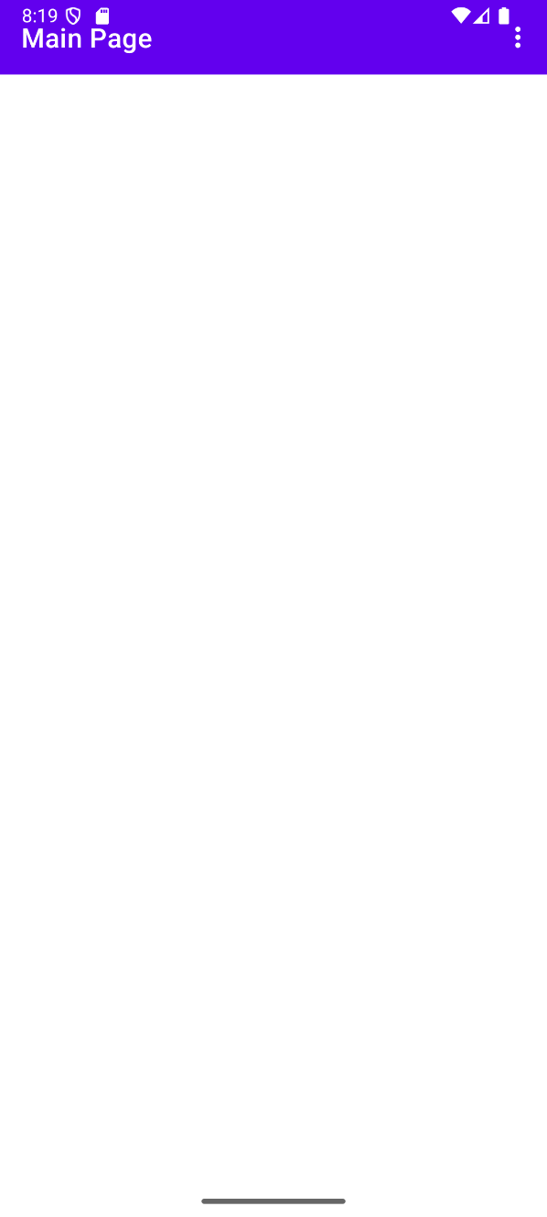 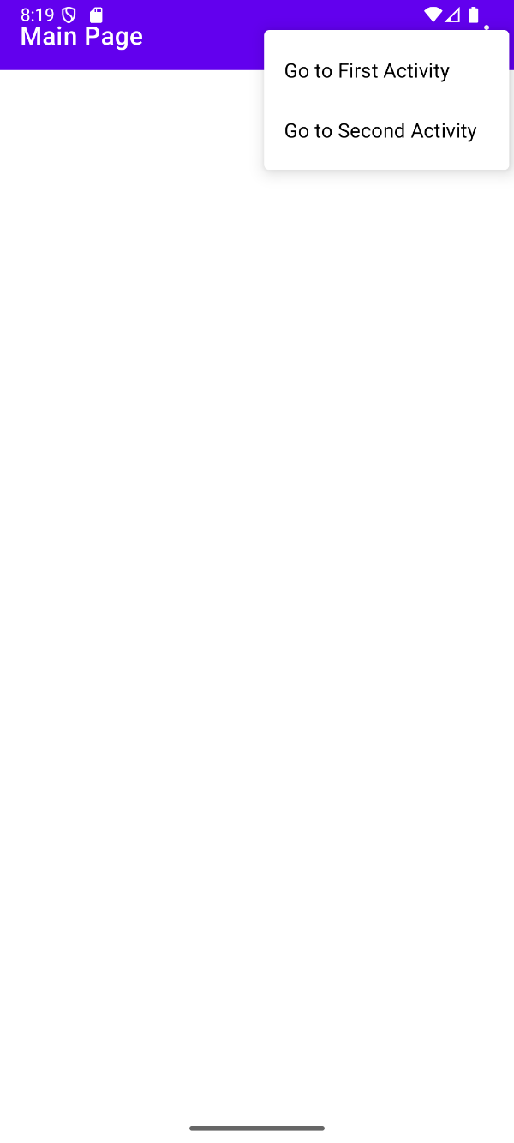

 

**CO5: Styles, themes, drawable resources, responsive design patterns**

**Experiment 16: "Working with Styles and Themes in Android”**

**Objective:** To learn how to apply to Android applications in order to maintain a consistent and attractive UI design.

**Question:** Design an Android application with multiple UI components (e.g., TextView, Button, EditText). Create custom in styles.xml to define properties such as . Apply a global (light or dark) to the entire app. Demonstrate how changing the theme updates the look and feel of all UI components consistently.

**MainActivity.java**

package com.example.exp16;

import android.content.SharedPreferences;

import android.os.Bundle;

import android.view.View;

import android.widget.Button;

import androidx.activity.EdgeToEdge;

import androidx.appcompat.app.AppCompatActivity;

import androidx.core.graphics.Insets;

import androidx.core.view.ViewCompat;

import androidx.core.view.WindowInsetsCompat;

public class MainActivity extends AppCompatActivity {

private boolean isDarkTheme;

@Override

protected void onCreate(Bundle savedInstanceState) {

// Load theme preference before setting content view

SharedPreferences prefs = getSharedPreferences("ThemePrefs", MODE_PRIVATE);

isDarkTheme = prefs.getBoolean("isDarkTheme", false);

// Apply the selected theme

setTheme(isDarkTheme ? R.style.AppTheme_Dark : R.style.AppTheme_Light);

super.onCreate(savedInstanceState);

setContentView(R.layout.activity_main);

// Theme toggle button logic

Button toggleButton = findViewById(R.id.themeToggleButton);

toggleButton.setOnClickListener(new View.OnClickListener() {

@Override

public void onClick(View v) {

isDarkTheme = !isDarkTheme;

prefs.edit().putBoolean("isDarkTheme", isDarkTheme).apply();

recreate(); // Recreate activity to apply new theme

}

});

}

}

**activity_main.xml**

<LinearLayout xmlns:android="http://schemas.android.com/apk/res/android"

android:layout_width="match_parent"

android:layout_height="match_parent"

android:orientation="vertical"

android:padding="16dp">

<TextView

style="@style/CustomTextView"

android:text=" Theme Switcher"

android:layout_width="wrap_content"

android:layout_height="wrap_content" />

<EditText

style="@style/CustomEditText"

android:hint="Enter your name"

android:layout_width="match_parent"

android:layout_height="wrap_content" />

<Button

style="@style/CustomButton"

android:text="Submit"

android:layout_width="wrap_content"

android:layout_height="wrap_content" />

<Button

android:id="@+id/themeToggleButton"

android:text="Toggle Theme Changer"

android:layout_width="wrap_content"

android:layout_height="wrap_content" />

</LinearLayout>

**styles.xml**

<resources>

<!-- Base application theme -->

<style name="AppTheme.Light" parent="Theme.MaterialComponents.DayNight.NoActionBar">

<item name="colorPrimary">#EE0000</item>

<item name="colorPrimaryVariant">#B30000</item>

<item name="colorOnPrimary">#FFFFFF</item>

<item name="android:textColor">#000000</item>

<item name="android:background">#FFFFFF</item>

</style>

<style name="AppTheme.Dark" parent="Theme.MaterialComponents.DayNight.NoActionBar">

<item name="colorPrimary">#00FB37</item>

<item name="colorPrimaryVariant">#00FF6F</item>

<item name="colorOnPrimary">#000000</item>

<item name="android:textColor">#FFFFFF</item>

<item name="android:background">#121212</item>

</style>

<!-- Custom UI component styles -->

<style name="CustomTextView">

<item name="android:textSize">20sp</item>

<item name="android:textStyle">bold</item>

<item name="android:layout_marginBottom">16dp</item>

</style>

<style name="CustomEditText">

<item name="android:padding">12dp</item>

<item name="android:backgroundTint">?attr/colorPrimary</item>

</style>

<style name="CustomButton">

<item name="android:backgroundTint">?attr/colorPrimary</item>

<item name="android:textColor">?attr/colorOnPrimary</item>

</style>

</resources>

**Output**

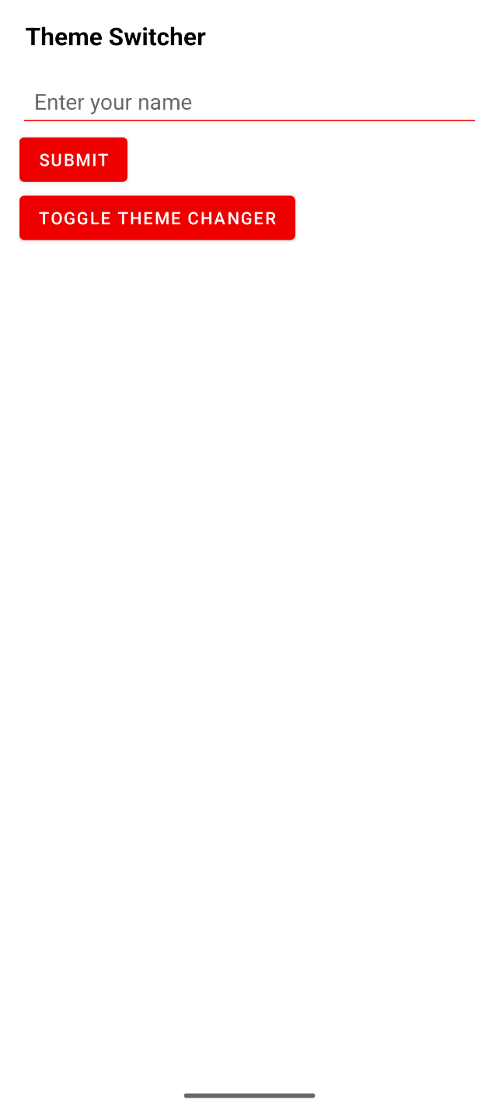 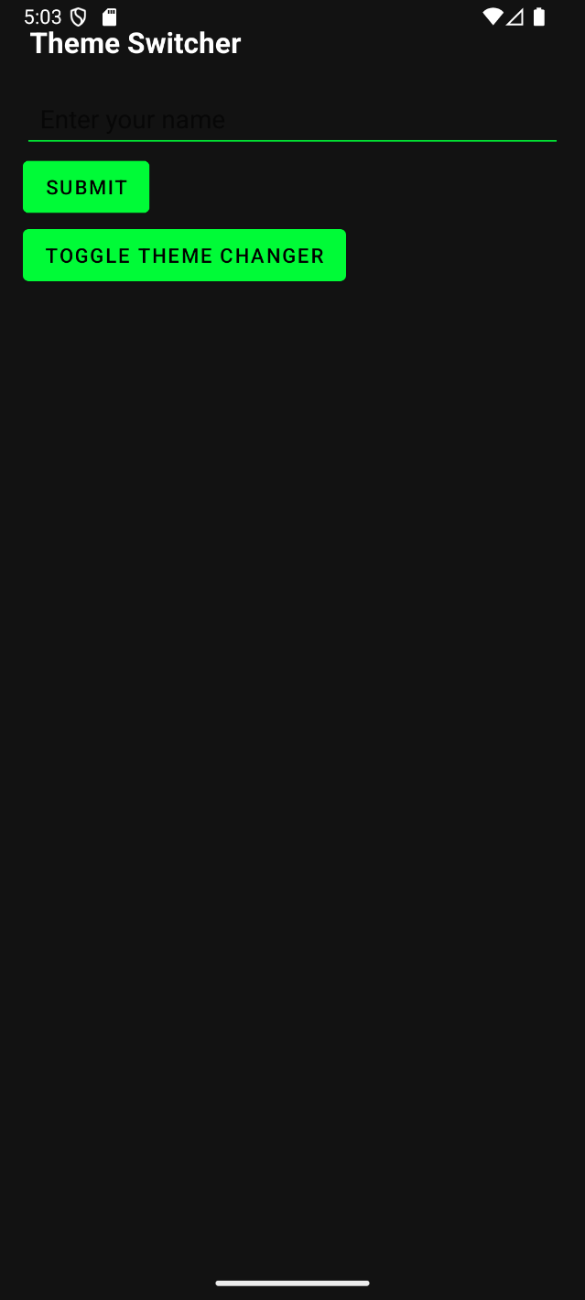

**Experiment 17: "Grid View & Alert Box”**

**Objective:** To learn how to display images in a GridView and show an Alert Box when an item is selected.

**Question:** Develop an application that uses a GridView with images. When an image is selected, display an Alert Box.

**MainActivity.java**

package com.example.exp17;

import android.content.Context;

import android.os.Bundle;

import android.view.View;

import android.widget.AdapterView;

import android.widget.BaseAdapter;

import android.widget.GridView;

import android.widget.ImageView;

import androidx.activity.EdgeToEdge;

import androidx.appcompat.app.AlertDialog;

import androidx.appcompat.app.AppCompatActivity;

import androidx.core.graphics.Insets;

import androidx.core.view.ViewCompat;

import androidx.core.view.WindowInsetsCompat;

public class MainActivity extends AppCompatActivity {

int[] imageIds = {

R.drawable.image1,

R.drawable.image2,

R.drawable.image3,

R.drawable.image4,

};

@Override

protected void onCreate(Bundle savedInstanceState) {

super.onCreate(savedInstanceState);

setContentView(R.layout.activity_main);

GridView gridView = findViewById(R.id.gridView);

gridView.setAdapter(new ImageAdapter(this));

gridView.setOnItemClickListener(new AdapterView.OnItemClickListener() {

@Override

public void onItemClick(AdapterView<?> parent, View view, int position, long id) {

showAlert(position);

}

});

}

private void showAlert(int position) {

new AlertDialog.Builder(this)

.setTitle("Selected Image")

.setMessage("Image" + (position + 1))

.setPositiveButton("OK", null)

.show();

}

class ImageAdapter extends BaseAdapter {

private Context context;

ImageAdapter(Context c) {

context = c;

}

public int getCount() {

return imageIds.length;

}

public Object getItem(int position) {

return imageIds[position];

}

public long getItemId(int position) {

return position;

}

public View getView(int position, View convertView, android.view.ViewGroup parent) {

ImageView imageView;

if (convertView == null) {

imageView = new ImageView(context);

imageView.setLayoutParams(new GridView.LayoutParams(300, 300));

imageView.setScaleType(ImageView.ScaleType.CENTER_CROP);

imageView.setPadding(8, 8, 8, 8);

} else {

imageView = (ImageView) convertView;

}

imageView.setImageResource(imageIds[position]);

return imageView;

}

}}

**activity_main.xml**

<GridView xmlns:android="http://schemas.android.com/apk/res/android"

android:id="@+id/gridView"

android:layout_width="match_parent"

android:layout_height="match_parent"

android:numColumns="auto_fit"

android:verticalSpacing="16dp"

android:horizontalSpacing="16dp"

android:padding="16dp"

android:gravity="center"

android:stretchMode="columnWidth" />

**Output**

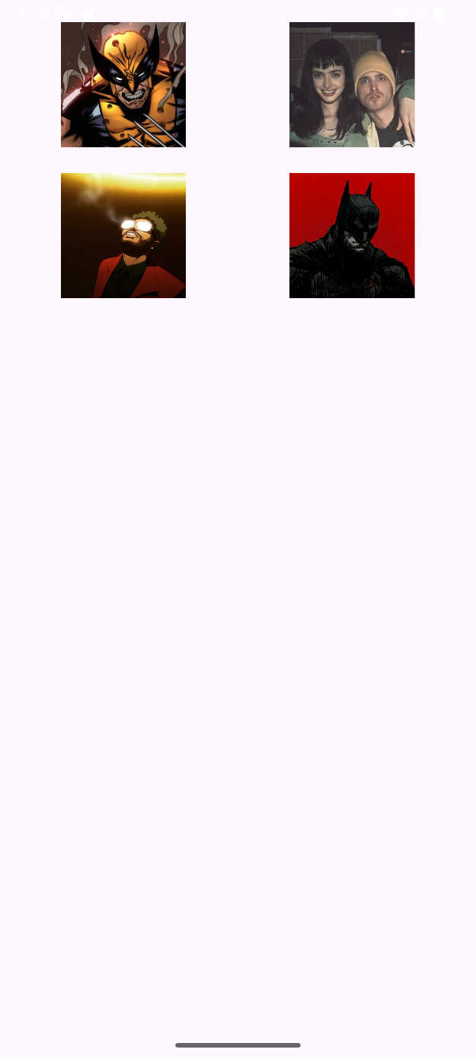 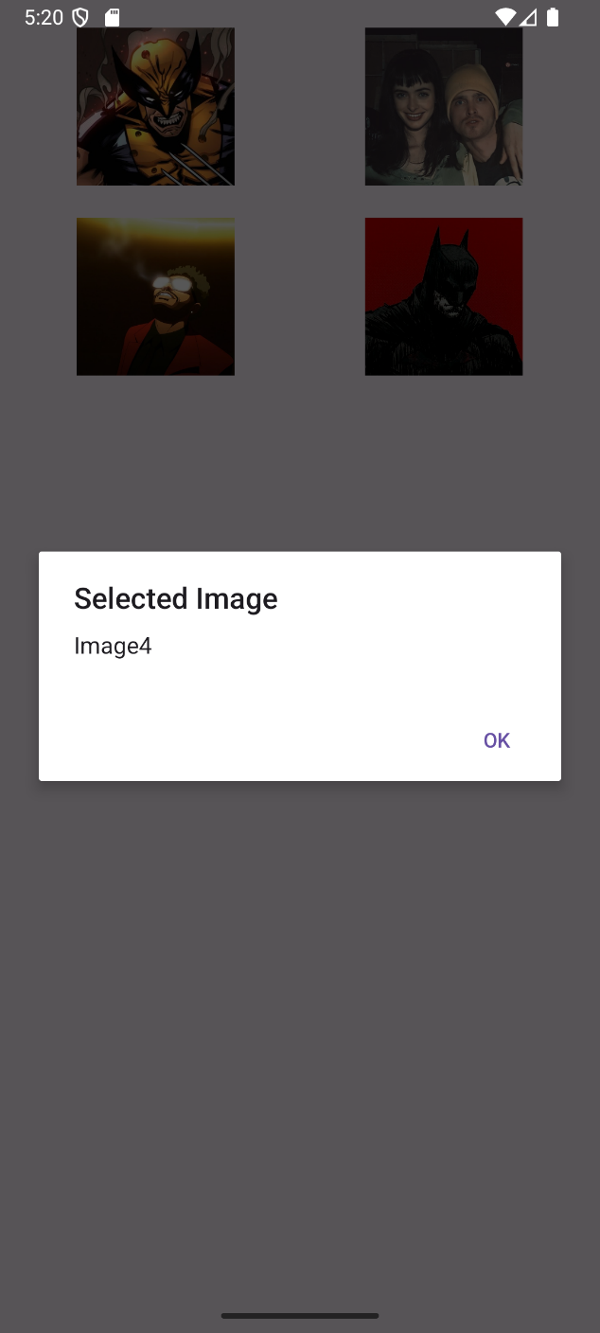

**Experiment 18: "Spinner Component with Event Handling”**

**Objective:** To learn how to implement a Spinner component (dropdown menu) and handle the user's selection.

**Question:** Develop an application that implements a Spinner component. Populate it with items and perform an action (event handling) when an item is selected.

**MainActivity.java**

package com.example.exp18;

import android.os.Bundle;

import android.view.View;

import android.widget.AdapterView;

import android.widget.ArrayAdapter;

import android.widget.Spinner;

import android.widget.TextView;

import androidx.activity.EdgeToEdge;

import androidx.appcompat.app.AppCompatActivity;

import androidx.core.graphics.Insets;

import androidx.core.view.ViewCompat;

import androidx.core.view.WindowInsetsCompat;

public class MainActivity extends AppCompatActivity {

String[] items = { "Choose a Player","Messi", "Ronaldo", "Neymar", "Xavi", "Iniesta" };

@Override

protected void onCreate(Bundle savedInstanceState) {

super.onCreate(savedInstanceState);

setContentView(R.layout.activity_main);

Spinner spinner = findViewById(R.id.mySpinner);

TextView selectedText = findViewById(R.id.selectedItemText);

ArrayAdapter<String> adapter = new ArrayAdapter<>(

this, android.R.layout.simple_spinner_item, items

);

adapter.setDropDownViewResource(android.R.layout.simple_spinner_dropdown_item);

spinner.setAdapter(adapter);

spinner.setOnItemSelectedListener(new AdapterView.OnItemSelectedListener() {

@Override

public void onItemSelected(AdapterView<?> parent, View view, int position, long id) {

String selected = items[position];

selectedText.setText("Selected Player: " + selected);

}

@Override

public void onNothingSelected(AdapterView<?> parent) {

selectedText.setText("No player selected");

}

});

}

}

**activity_main.xml**

<?xml version="1.0" encoding="utf-8"?>

<LinearLayout xmlns:android="http://schemas.android.com/apk/res/android"

android:layout_width="match_parent"

android:layout_height="match_parent"

android:orientation="vertical"

android:padding="24dp"

android:gravity="center">

<TextView

android:id="@+id/selectedItemText"

android:layout_width="wrap_content"

android:layout_height="wrap_content"

android:text="Player Selected:"

android:textSize="18sp"

android:layout_marginBottom="20dp" />

<Spinner

android:id="@+id/mySpinner"

android:layout_width="wrap_content"

android:layout_height="wrap_content"

android:spinnerMode="dropdown" />

</LinearLayout>

**Output**

 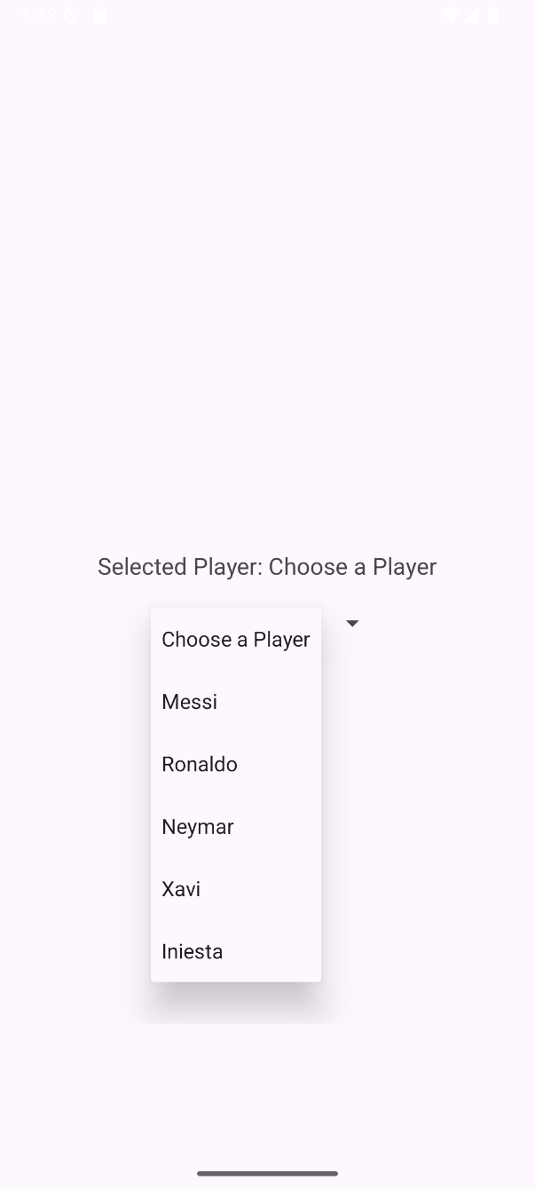



**Experiment 19: "Date and Time Picker Dialogs”**

**Objective:** To learn how to implement DatePickerDialog and TimePickerDialog to allow users to select dates and times.

**Question:** Create an application with buttons to open a DatePickerDialog and a TimePickerDialog. Display the selected date and time in TextViews.

**MainActivity.java**

package com.example.exp19;

import android.app.DatePickerDialog;

import android.app.TimePickerDialog;

import android.os.Bundle;

import android.view.View;

import android.widget.Button;

import android.widget.DatePicker;

import android.widget.TextView;

import android.widget.TimePicker;

import androidx.activity.EdgeToEdge;

import androidx.appcompat.app.AppCompatActivity;

import androidx.core.graphics.Insets;

import androidx.core.view.ViewCompat;

import androidx.core.view.WindowInsetsCompat;

import java.util.Calendar;

public class MainActivity extends AppCompatActivity {

Button btnDate, btnTime;

TextView tvDate, tvTime;

@Override

protected void onCreate(Bundle savedInstanceState) {

super.onCreate(savedInstanceState);

setContentView(R.layout.activity_main);

btnDate = findViewById(R.id.btnDate);

btnTime = findViewById(R.id.btnTime);

tvDate = findViewById(R.id.tvDate);

tvTime = findViewById(R.id.tvTime);

btnDate.setOnClickListener(new View.OnClickListener() {

@Override

public void onClick(View view) {

openDatePicker();

}

});

btnTime.setOnClickListener(new View.OnClickListener() {

@Override

public void onClick(View view) {

openTimePicker();

}

});

}

private void openDatePicker() {

final Calendar calendar = Calendar.getInstance();

int year = calendar.get(Calendar.YEAR);

int month = calendar.get(Calendar.MONTH);

int day = calendar.get(Calendar.DAY_OF_MONTH);

DatePickerDialog datePickerDialog = new DatePickerDialog(

MainActivity.this,

new DatePickerDialog.OnDateSetListener() {

@Override

public void onDateSet(DatePicker view, int year, int month, int dayOfMonth) {

String date = dayOfMonth + "/" + (month + 1) + "/" + year;

tvDate.setText("Selected Date: " + date);

}

}, year, month, day);

datePickerDialog.show();

}

private void openTimePicker() {

final Calendar calendar = Calendar.getInstance();

int hour = calendar.get(Calendar.HOUR_OF_DAY);

int minute = calendar.get(Calendar.MINUTE);

TimePickerDialog timePickerDialog = new TimePickerDialog(

MainActivity.this,

new TimePickerDialog.OnTimeSetListener() {

@Override

public void onTimeSet(TimePicker view, int hourOfDay, int minute) {

String time = String.format("%02d:%02d", hourOfDay, minute);

tvTime.setText("Selected Time: " + time);

}

}, hour, minute, true);

timePickerDialog.show();

}

}

**activity_main.xml**

<?xml version="1.0" encoding="utf-8"?>

<LinearLayout

xmlns:android="http://schemas.android.com/apk/res/android"

android:orientation="vertical"

android:padding="24dp"

android:layout_width="match_parent"

android:layout_height="match_parent">

<Button

android:id="@+id/btnDate"

android:layout_width="match_parent"

android:layout_height="wrap_content"

android:text="Select Date" />

<TextView

android:id="@+id/tvDate"

android:layout_width="match_parent"

android:layout_height="wrap_content"

android:text="Selected Date: "

android:textSize="18sp"

android:paddingTop="16dp" />

<Button

android:id="@+id/btnTime"

android:layout_width="match_parent"

android:layout_height="wrap_content"

android:text="Select Time"

android:layout_marginTop="24dp" />

<TextView

android:id="@+id/tvTime"

android:layout_width="match_parent"

android:layout_height="wrap_content"

android:text="Selected Time: "

android:textSize="18sp"

android:paddingTop="16dp" />

</LinearLayout>

**Output**

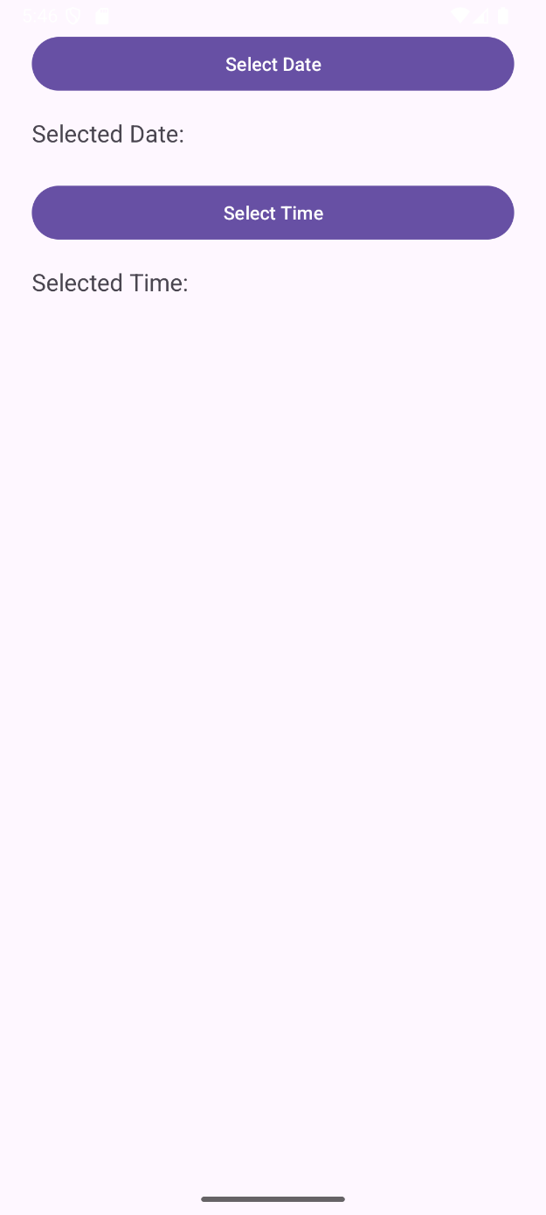 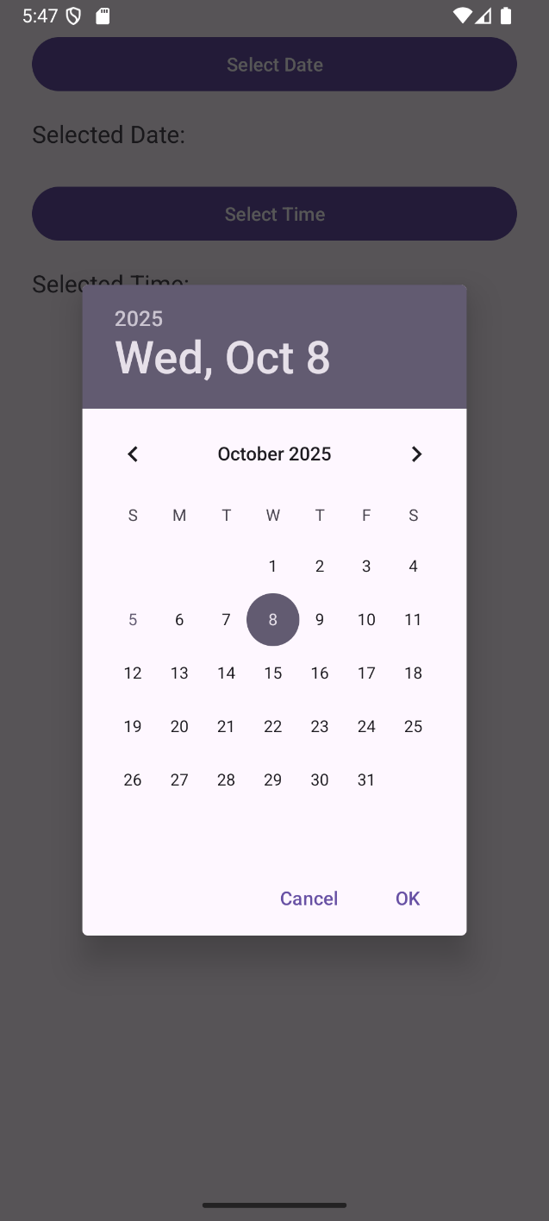

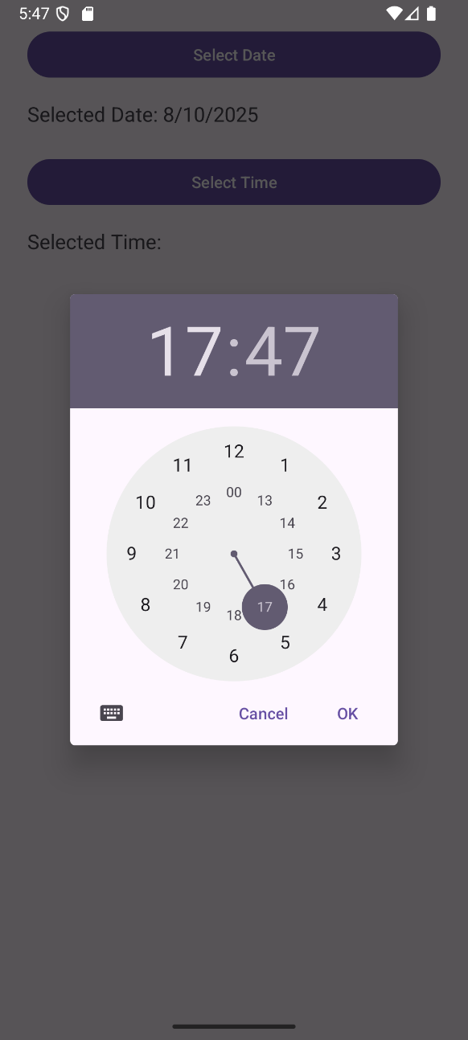 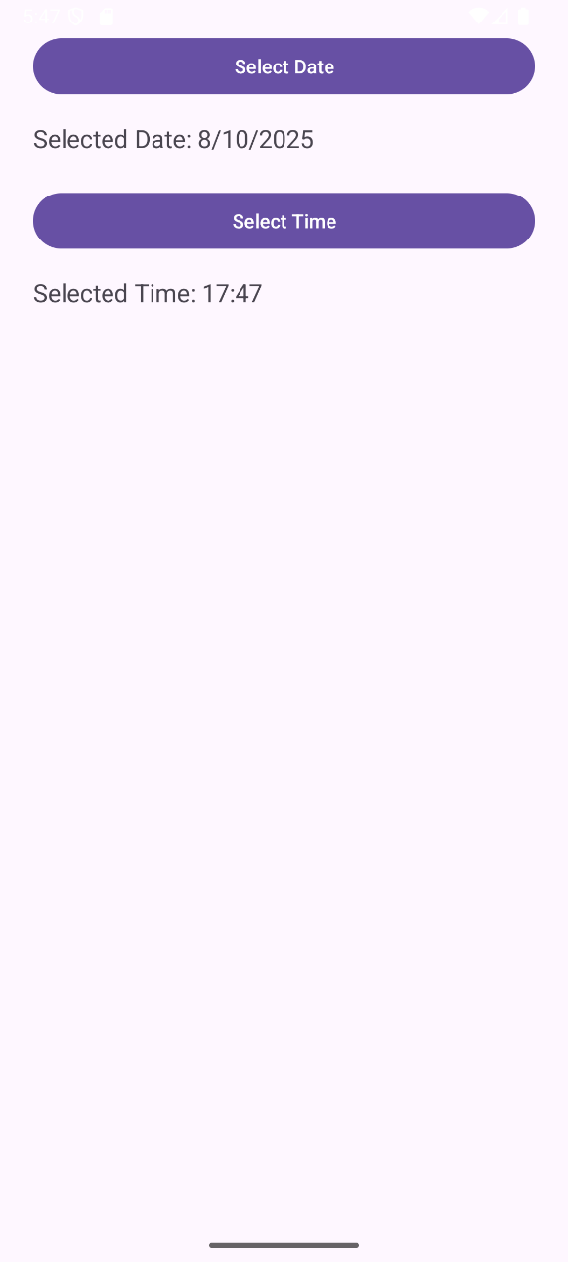

**Experiment 20: "Fragments Application”**

**Objective:** To learn how to develop an application using Fragments to manage different parts of UI.

**Question:** Develop an application using Fragments to show different content areas within a single activity.

**MainActivity.java**

package com.example.exp20;

import android.os.Bundle;

import android.view.View;

import android.widget.Button;

import androidx.activity.EdgeToEdge;

import androidx.appcompat.app.AppCompatActivity;

import androidx.core.graphics.Insets;

import androidx.core.view.ViewCompat;

import androidx.core.view.WindowInsetsCompat;

import androidx.fragment.app.Fragment;

import androidx.fragment.app.FragmentTransaction;

public class MainActivity extends AppCompatActivity {

Button btnFragmentOne, btnFragmentTwo;

@Override

protected void onCreate(Bundle savedInstanceState) {

super.onCreate(savedInstanceState);

setContentView(R.layout.activity_main);

btnFragmentOne = findViewById(R.id.btnFragmentOne);

btnFragmentTwo = findViewById(R.id.btnFragmentTwo);

loadFragment(new FragmentOne());

btnFragmentOne.setOnClickListener(new View.OnClickListener() {

@Override

public void onClick(View view) {

loadFragment(new FragmentOne());

}

});

btnFragmentTwo.setOnClickListener(new View.OnClickListener() {

@Override

public void onClick(View view) {

loadFragment(new FragmentTwo());

}

});

}

private void loadFragment(Fragment fragment) {

FragmentTransaction transaction = getSupportFragmentManager().beginTransaction();

transaction.replace(R.id.fragmentContainer, fragment);

transaction.commit();

}

}

**FragmentOne.java**

package com.example.exp20;

import android.os.Bundle;

import androidx.fragment.app.Fragment;

import android.view.LayoutInflater;

import android.view.View;

import android.view.ViewGroup;

import android.widget.ImageView;

import android.widget.TextView;

public class FragmentOne extends Fragment {

@Override

public View onCreateView(LayoutInflater inflater, ViewGroup container,

Bundle savedInstanceState) {

View view = inflater.inflate(R.layout.fragment_one, container, false);

TextView tv = view.findViewById(R.id.tvFragment);

tv.setText("This is Fragment One");

ImageView img = view.findViewById(R.id.imgFragment);

img.setImageResource(R.drawable.image3);

return view;

}

}

**FragmentTwo.java**

package com.example.exp20;

import android.os.Bundle;

import androidx.fragment.app.Fragment;

import android.view.LayoutInflater;

import android.view.View;

import android.view.ViewGroup;

import android.widget.ImageView;

import android.widget.TextView;

public class FragmentTwo extends Fragment {

@Override

public View onCreateView(LayoutInflater inflater, ViewGroup container,

Bundle savedInstanceState) {

View view = inflater.inflate(R.layout.fragment_two, container, false);

TextView tv = view.findViewById(R.id.tvFragment);

tv.setText("This is Fragment Two");

ImageView img = view.findViewById(R.id.imgFragment);

img.setImageResource(R.drawable.image4);

return view;

}

}

**activity_main.xml**

<?xml version="1.0" encoding="utf-8"?>

<LinearLayout

xmlns:android="http://schemas.android.com/apk/res/android"

android:orientation="vertical"

android:layout_width="match_parent"

android:layout_height="match_parent"

android:padding="16dp">

<LinearLayout

android:orientation="horizontal"

android:layout_width="match_parent"

android:layout_height="wrap_content"

android:gravity="center">

<Button

android:id="@+id/btnFragmentOne"

android:layout_width="wrap_content"

android:layout_height="wrap_content"

android:text="Fragment One" />

<Button

android:id="@+id/btnFragmentTwo"

android:layout_width="wrap_content"

android:layout_height="wrap_content"

android:text="Fragment Two"

android:layout_marginStart="16dp" />

</LinearLayout>

<FrameLayout

android:id="@+id/fragmentContainer"

android:layout_width="match_parent"

android:layout_height="0dp"

android:layout_weight="1"

android:layout_marginTop="16dp" />

</LinearLayout>

**fragment_one.xml**

<?xml version="1.0" encoding="utf-8"?>  
<FrameLayout xmlns:android="http://schemas.android.com/apk/res/android"  
 android:layout_width="match_parent"  
 android:layout_height="match_parent"  
 android:background="#FFCDD2"  
 android:padding="16dp">  
 <LinearLayout  
 android:layout_width="match_parent"  
 android:layout_height="match_parent"  
 android:orientation="vertical"  
 android:gravity="center">  
 <TextView  
 android:id="@+id/tvFragment"  
 android:layout_width="wrap_content"  
 android:layout_height="wrap_content"  
 android:text="Fragment One"  
 android:textSize="24sp"  
 android:layout_marginBottom="16dp"/>  
 <ImageView  
 android:id="@+id/imgFragment"  
 android:layout_width="200dp"  
 android:layout_height="200dp"  
 android:src="@drawable/image3"  
 android:contentDescription="Fragment One Image"  
 android:scaleType="centerCrop"/>  
 </LinearLayout>  
</FrameLayout>

**fragment_two.xml**

<?xml version="1.0" encoding="utf-8"?>

<FrameLayout xmlns:android="http://schemas.android.com/apk/res/android"

android:layout_width="match_parent"

android:layout_height="match_parent"

android:background="#C8E6C9"

android:padding="16dp">

<LinearLayout

android:layout_width="match_parent"

android:layout_height="match_parent"

android:orientation="vertical"

android:gravity="center">

<TextView

android:id="@+id/tvFragment"

android:layout_width="wrap_content"

android:layout_height="wrap_content"

android:text="Fragment Two"

android:textSize="24sp"

android:layout_marginBottom="16dp"/>

<ImageView

android:id="@+id/imgFragment"

android:layout_width="200dp"

android:layout_height="200dp"

android:src="@drawable/image4"

android:contentDescription="Sample Image"

android:scaleType="centerCrop"/>

</LinearLayout>

</FrameLayout>

**Output**

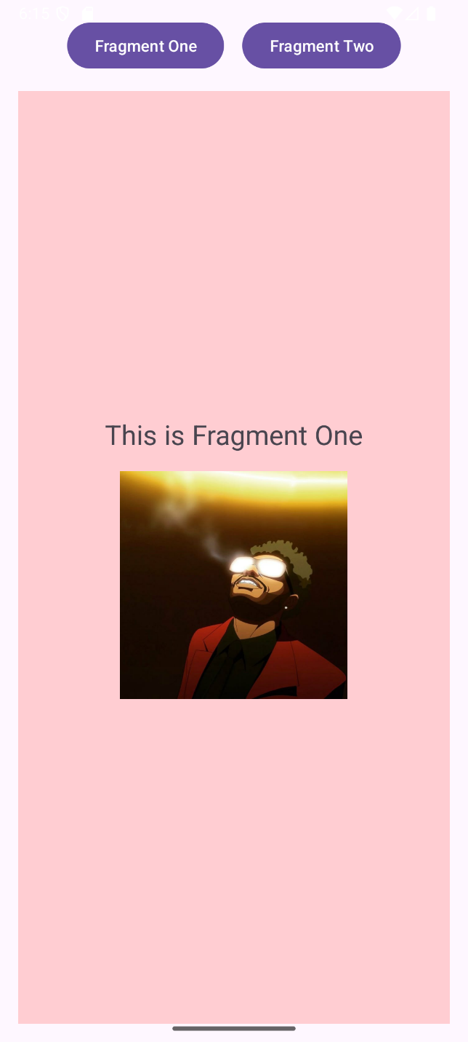 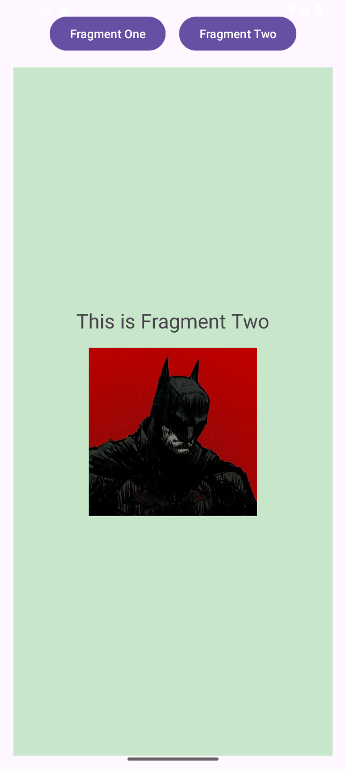

**Experiment 21: "Navigation Drawer Implementation”**

**Objective:** To learn how to implement a Navigation Drawer for app navigation.

**Question:** Implement a Navigation Drawer in your application to allow users to navigate between different sections.

**MainActivity.java**